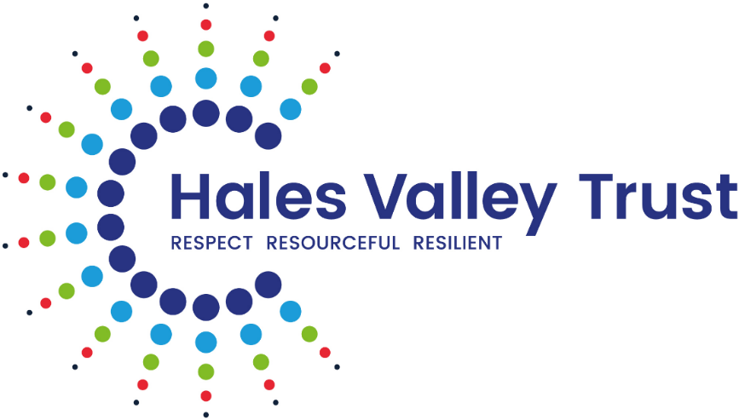

Policy for Supporting Pupils with Medical Conditions

Policy Tracker – Responsibility for monitoring this policy:
SENCO Forum
(Reviewed annually – date of next review June 2026)

Date of review | Reviewed By: | Role | Date Approved by the Governing Board/committee
22/5/19 | Special Educational Needs Co-ordinators  Jeannette Mackinney | Special Educational Needs  CEO | June 2019
20/05/2020 | Special Educational Needs Co-ordinators  Jeannette Mackinney | Special Educational Needs  CEO | June 2020
24.6.21 | Special Educational Needs Co-ordinators  Jeannette Mackinney  Anne Shipley | Special Educational Needs  CEO  Pupil Welfare Officer | June 2021
23.5.22 | Special Educational Needs Co-ordinators  Jeannette Mackinney  Anne Shipley | Special Educational Needs  CEO  Pupil Welfare Officer | July 2022
16.6.2023 | Anne Shipley  Emma Tolley | Pupil Welfare Officer  Head of Academic Outcomes and Inclusion | July 2023
20.6.2024 | Emma Tolley  Special needs co ordinators | Head of Academic Outcomes and Inclusion | July 2024
25.6.2025 | Emma Tolley  Special needs co ordinators | Head of Academic Outcomes and Inclusion | July 2025

Hales Valley Trust /NHS Partnership
Withymoor Primary School

The health of our pupils is of paramount importance. Poor health can result in a barrier to learning and it is our aim to support Dudley NHS Primary Care in regularly monitoring the health and well-being of individuals.
Our partnership with the NHS enables us to provide facilities for a number of timed checks to be carried out. For your information these are listed below:
Service Manager
Laura Bickley
Tel: 01384 408990
Email: laura.bickley@nhs.net
- The Dudley South NHS Primary Care Trust monitors all school nurse’s caseloads regularly and updates when necessary. This reflects in a good medical liaison between Primary and Secondary Schools.
- It is important that all medical issues are transferred between schools.
Withymoor Primary’s School Nurse can be contacted on the phone number: 01384 408990

The care scheme of work that the School Health Advisor offers is:
School entry (Foundation which is a child’s first year at school)
- Liaison with Class Teacher/First Aid Coordinator/SENCO.
- Health questionnaire to all parents.
- Measurement of height and weight.
- Hearing Sweep test.
- Children who are highlighted with a medical/developmental problem will be offered a selective school entry health assessment or referred to the appropriate agency.
Throughout Primary School
- Referrals from education staff.
- Reviews of height and weight will be offered.
- Regular ‘drop in’ sessions for children and parents.
- Flu immunisations.
Year 6
- Confidential health questionnaire to all parents on transfer to secondary school.
- Measurement of height/weight.
Withymoor School Primary has an excellent working relationship with Amanda Stanier.

Primary School’s named SENCO: Mrs. Lian Barrett
SEND assistant: Mrs. Anna Winstanley
Primary School’s named First Aid Co-Ordinator: Mrs. Shelley Whitehall
We are working towards promoting good health and ensuring children with any health problems are dealt with in a caring, confidential manner.

Table of Contents
 | Page
- Supporting Pupils with Medical  Conditions and Medical Policy | 6
- Anaphylactic Policy | 20
- Asthma Policy | 23
- Epilepsy Policy | 33
- Diabetes Policy | 37
- First Aid Policy | 39
- Spillage and Bodily Fluids Policy | 48
- Sharps Policy | 50

Supporting Pupils with Medical Conditions

Introduction
The Board of Directors ensures that pupils with medical conditions receive appropriate care and support at school. This policy has been developed in line with the Department for Education’s guidance Supporting Pupils with Medical Conditions at School, published in September 2014 (last updated August 2017). Ofsted places a clear emphasis on meeting the needs of pupils with SEN and Disabilities and this includes children with medical conditions.
- The Children and Families Act 2014 includes a duty for schools to support children with medical conditions.
- The DfE publication Supporting Pupils with Medical Conditions at Schools published in December 2015 includes statutory guidance for governing bodies of maintained schools and proprietors of academies in England.
- Where children have a disability, the requirements of the Equality Act 2010 will apply. Where children have an identified special need, the SEND Code of Practice 2014 will also apply.
- All schools across Hales Valley Trust aim to ensure that all children with medical conditions, in terms of both physical and mental health, are supported to play a full and active role in school life, remain healthy and achieve their academic potential.
- All children have a right to full access to education, including school trips and physical education.
- We recognise that medical conditions may impact on social and emotional development as well as having educational implications.
- Hales Valley Trust School staff will consult health and social care professionals, pupils and parents to ensure that the needs of children with medical conditions are effectively supported.

Key Roles and Responsibilities

The Local Authority (LA) is responsible for:
- Promoting co-operation between relevant partners and stakeholders regarding supporting pupils with medical conditions.
- Providing support, advice and guidance to schools and their staff.
- Making alternative arrangements for the education of pupils who need to be out of school for fifteen days or more due to a medical condition.
The Board of Directors is responsible for:
- The developing and reviewing the Supporting Pupils with Medical Conditions Policy and procedures in the trust.
- Ensuring that the school’s Admissions Policy and Supporting Pupils with Medical Conditions Policy, as written, does not discriminate on any grounds including, but not limited to: ethnicity/national origin, culture, religion, gender, disability or sexual orientation.
The Executive Headteacher/Headteacher
- The overall implementation of the Supporting Pupils with Medical Conditions Policy and procedures in the school.
- Ensuring that the school’s Admissions Policy and Supporting Pupils with Medical Conditions Policy, as written, does not discriminate on any grounds including, but not limited to: ethnicity/national origin, culture, religion, gender, disability or sexual orientation.
- Informing relevant staff of medical conditions and preventative or emergency measures required so that staff can recognise and act quickly when a problem occurs.
- Guaranteeing that information and teaching support materials regarding supporting pupils with medical conditions are available to members of staff with responsibilities under this policy.
- Ensuring that arrangements are in place to support pupils with medical conditions so they can access and enjoy the same opportunities at school as any other child.
- Ensuring the level of insurance in place reflects the level of risk.
- Ensuring that the focus is on the needs of each individual child and how their medical condition impacts on their school life.
- Keeping written records of any and all medicines administered to individual pupils and across the school population.
- Ensuring that the school’s policy for supporting pupils with medical conditions is shared with staff in whole school awareness training and that induction arrangements for new staff are in place.
- Arranging and monitoring and keeping a record of training for identified staff.
- Ensuring that necessary information about medical conditions is communicated to supply staff where appropriate.
- Completing risk assessment for school visits and other activities outside of the normal timetable with support and guidance from, Physical Impairment and Medical Inclusion Services (PIMIS) and Elite Safety in Education.
- Monitoring and reviewing Individual Healthcare Plans.
- Working together with parents, pupils, healthcare professionals and other agencies.
- Where necessary work flexibly to ensure that a child receives appropriate education in line with their particular health needs. For example, allowing a child to attend school part time in combination with alternative provision arranged by the local authority.
- To ensure that the policy for supporting pupils with medical conditions in school is implemented and reviewed.

The Head of School and SENCO is responsible for:

- The day-to-day implementation and management of the Supporting Pupils with Medical Conditions Policy and procedures of the school.
- Making sure all staff are aware and understand this policy and their role in its implementation.
- Liaising with healthcare professionals regarding the training required for staff.
- Making staff, who need to know, aware of a child’s medical condition.
- Developing Individual Healthcare Plans (IHCPs) in partnership with the school Nurse and parents.
- Ensuring that short- or long-term risk assessments and PEEPS are developed in consultation with parents for pupils with ongoing medical needs or after receiving medical treatment. For example, broken limbs.
- Ensuring a sufficient number of trained members of staff are available to implement the policy and deliver IHCPs in normal, contingency and emergency situations.
- Liaising locally with lead clinicians on appropriate support.
- Have overall responsibility for the delivery of individual health care plans.
- Ensure all staff have sufficient school insurance to carry out these duties.
- Ensuring the regular checks are carried out on all medication stored on site to ensure correct labelling i.e. expiry dates, dosage and how often is in place.
- The school nurse service are no longer completing annual updates to care plans, they are only completing when parents inform them of a change.
- In line, with this, schools are no longer completing Annual Asthma Care Plans either but are sending them home to be checked and amended if parents inform the school of a change.
‘In line with recommendations from the Department of Health and the Use of Medicines Guidance in Schools Policy, it is the school’s responsibility to ensure Care plans are in place and there is a named person, in school, responsible for collating medical information, individual health care plans and asthma care plans, the named person responsible for this at Withymoor Primary School is Mrs. Winstanley is responsible for making sure that all care plans are reviewed ready for September and this is then checked by a named senior leader Mrs. L. Smith in school. School records that the care plans have been checked and that the changes have been followed up, this is recorded on CPOMS. Mrs. S. Whitehall organises for an annual BROMCOM notification to go out to parents to establish whether there are any changes to medical needs.
This includes making annual contact with parents/carers to check for any changes. If any updates / changes are identified, schools must inform the School Nurse, who will then contact the parent/carer to make the necessary amendments.’
Please note:
- Anaphylaxis Careplans will be reviewed and updated annually by School Nurses as recommended by Allergy UK.
- Diabetes Careplans will remain the responsibility of the Specialist Diabetes Team within the hospital setting.

Staff members are responsible for:
- Taking appropriate steps to support children with medical conditions.
- Where necessary, making reasonable adjustments to include pupils with medical conditions into lessons.
- Administering medication (subject to having received appropriate training from NOS or National college)
- Undertaking training to achieve the necessary competency for supporting pupils with medical conditions, if they have agreed to undertake that responsibility.
- Familiarising themselves with procedures detailing how to respond when they become aware that a pupil with a medical condition needs help.
- Follow risk assessments, care plans and PEEPS that have been drawn up for individual pupils.
- Making reasonable adjustments in order that children with medical needs can participate fully and safely on trips and visits by carrying out risk assessments and seeking advice from a range of external agencies including PIMIS and Elite Safety in Education.
- Informing parents/carers if their child has been unwell at school.

Any teacher or support staff member may be asked to provide support to a child with a medical condition, including administering medicines.

School Nurses are responsible for:
- Notifying the school when a child has been identified with requiring support in school due to a medical condition.
- Liaising locally with lead clinicians on appropriate support.
- Providing support for staff on implementing a child’s individual health care plan and providing advice and liaison, including with regard to training.
- Have overall responsibility for the development of individual health care plans and making any annual required changes following on from parents notifying them of a change.
- Anaphylaxis Careplans will be reviewed and updated annually by School Nurses as recommended by Allergy UK.
- Diabetes Careplans will remain the responsibility of the Specialist Diabetes Team within the hospital setting.

Parents and carers are responsible for:

- Keeping the school informed about any changes, or new diagnosis to their child/children’s health.
- Completing an administration of medication form for school to administer prescribed medicine before bringing prescribed medication into school.
- Providing the school with the prescribed medication their child requires and keeping it up to date.
School will carry out regular checks on all medication stored on site to ensure correct labelling i.e. expiry dates, dosage and how often is in place. However, if a child requires emergency medication (such as an Auto injector or an inhaler) and this medication is out of date, then staff will administer this in the absence of any appropriate medicine.)
- Collecting any leftover prescribed medicine at the end of the course or year.
- Discussing prescribed medications with their child/children prior to requesting that a staff member administers the medication.
- Where necessary, developing an IHCP for their child in collaboration with the Head teacher, SENCO, other staff members and healthcare professionals and updating the school and school nurse of any changes or amendments which need to be made.
- To ensure that emergency contact information is always up to date and accurate, parents need to be aware of the importance of letting the school know of any change to emergency contact information and that they are always contactable in the event of an emergency. We reserve the right to test emergency contact numbers and if parents/carers are not available/contactable then the child could be asked to remain at home until the issues are resolved.
- Ensuring their child attends school on a regular basis.
Definitions
Prescription medication is defined as any drug or device prescribed by a doctor. A staff member is defined as any member of staff employed by the school.
Training of Staff
- Staff will receive advice on the Supporting Pupils with Medical Conditions and the School Medical Policy as part of their induction.
- Staff will receive regular and ongoing training as part of their development, only staff with administration of medication training may administer medication to a child, unless it is an inhaler or an Autoinjector (all school staff will be trained annually to administer an inhaler and an autoinjector). Any new staff will receive the training as part of their induction.
- Staff who undertake responsibilities under this policy will receive the training from the appropriate healthcare professionals or Elite Safety in Education/NOS/National college
- No staff member may administer prescription medicines or undertake any healthcare procedures without written consent from parents/carers.
- No staff member may administer drugs by injection unless they have received training in this responsibility.
- A record of staff training will be kept.
The role of the child
- If pupils refuse to take medication or to carry out a necessary procedure, parents will be informed so that alternative options can be explored. This will be documented by school.
- Where appropriate, pupils will be encouraged to carry their medication and take it under the supervision of trained staff.
- Pupils with medical conditions will be consulted about their medical support needs.

Procedure when notification received that pupil has a medical condition

- Arrangements to support medical needs should be in place in time for a child to start the school term.
- In cases where there has been a new diagnosis or a child has moved school mid-term, every effort will be made to ensure that arrangements are put in place within two weeks. During this period if the child already attends the school, the school has the right to refuse the child entry until staff training has been completed and an IHCP has been drawn up. During this time, work will be provided for the child to do at home.
- The named person will liaise with relevant individuals, including as appropriate, parents/carers, the individual pupil, health professionals and other agencies to decide on the support to be provided to the child.

Individual Healthcare Plans (IHCPs)
- Where necessary, an IHCP will be developed in collaboration with the pupil, parents/carers, relevant school staff and medical professionals.
- All IHCPs need to be reviewed every 12 months or sooner if there are significant changes to the child’s care, with each review being signed by the healthcare professionals involved in the individual child’s care and parents/carers.
- Any change a parent/carer wants to make to an IHCP needs to be via a written medical letter from a healthcare professional.
- IHCPs will be easily accessible whilst preserving confidentiality.
- Where a pupil has an Education, Health and Care plan (EHCP), the IHCP will be linked to it or become part of it.
- Where a child is returning from a period of hospital education or alternative provision or home tuition, we will work with the LA and education provider to ensure that the IHCP identifies the support the child needs to reintegrate.
Following an operation or absence longer than 4 weeks, before the return to school:
- There will need to be a written medical letter stating that the pupil is fit to return to school and outlining any special considerations of that return to school.
- The pupil will return to school only when their medical care has been reviewed by a healthcare professional (including the implementation of an IHCP if applicable) and a return to school meeting with parents.
- Where a child has an IHCP, this will clearly define what constitutes an emergency and explain what to do.

Medicines
- Where possible, it is preferable for medicines to be prescribed in frequencies that allow the pupil to take them outside of school hours.
- If this is not possible and the prescribed medicines require 4 or more dosages per day, then the school staff will administer one of these doses during the school day, usually around the middle of the day.
- Prior to staff members administering any medication, the parents/carers of the child must complete and sign an administration of medicines form for the school to administer the medicine.
- All medication must be brought in through the school office where appropriate procedures will be followed, no medication will be accepted via the classroom or on the playground.
- As a school, we will assess the level of training we feel is required for staff to administer medicines. Staff must have administration of medication training from NOS/National college at the very least.
- Prescribed medicines need to be fully labelled and it is not appropriate for them to be carried by the child, they will be stored safely either in a fridge or cupboard.
- Prescribed medicines MUST be in date, labelled, and provided in the original container (except in the case of insulin which may come in a pen or pump) with dosage instructions. Prescribed medicines which do not meet these criteria will not be administered.
- Any medications left over at the end of the course will be returned to the child’s parents or safely disposed of if expiry date is reached.
- Medication must not be brought into school without a prescription label. If this does happen it will be kept in the school office for the parent to collect. Staff will not administer medication without it being prescribed by a doctor. However, in the event of a child needing Paracetamol or Ibuprofen for short term pain relief, after a significant injury or operation, then trained staff may administer this once a day (below 500mg), referring to the instructions on the box. Parent/Carer complete an administration of medication form.
- Written records will be kept of any medication administered to children. Pupils will never be prevented from accessing their medication when needed and this will always be under the supervision of an adult. If the medication does not meet the requirements under the administration of medications training, medication will not be given and parents will be contacted immediately.
- School cannot be held responsible for side effects that occur when medication is taken correctly.
- Non-emergency medication will be stored appropriately in a locked cabinet/room.
- Emergency medication will be accessible to the child at all times.
OVER THE COUNTER MEDICATION
- In order for us to allow children into school with minor ailments, short term, over the counter medication may be accepted, this will be at the discretion of SLT and reviewed on a case to case basis.
- Where possible, it is preferable for over the counter medicines to be taken in frequencies that allow the pupil to take them outside of school hours.
- If this is not possible, and the medicines require 4 or more dosages per day, then the school staff will administer one of these doses during the school day, usually around the middle of the day.
- Parents must complete an administration of medication form before any medication can be given.
- School may liaise with their school Nurse to seek advice on over the counter medication and the period of time this may be taken.
- Over the counter medication can only be given in school for a maximum of 1 week, if the child requires a longer course, parents will be advised to seek medical advice.
- Over the counter medication MUST be in its original packaging, with the instruction label/leaflet available. Staff will follow the instructions on the medication leaflet/label along with the administration of medicine form completed by parents. If there is a conflict in this, staff will follow the instructions on the medication.

Emergencies
Medical emergencies will be dealt with under the school’s emergency procedure.
A copy of this information will be displayed in the school office:
- Request an ambulance – dial 999 and be ready with the information below. Speak slowly and clearly and be ready to repeat information if asked:
- The school’s telephone number
- Your name
- Your location
- Provide the exact location of the patient within the school.
- Provide the name of the child and a brief description of their symptoms.
- Inform ambulance control of the best entrance to use and state that the crew will be met and taken to the patient.
- Ask office staff to contact premises to open relevant gates for entry.
- Contact the parents to inform them of the situation.
- A member of staff should stay with the pupil until the parent/carer arrives. If a parent/carer does not arrive before the pupil is transported to hospital, a member of staff should accompany the child in the ambulance.
- It is the parent’s/carer’s responsibility to ensure that all medication brought into school is in date and labelled correctly at all times. School will carry out regular checks on all medication stored on site to ensure correct labelling i.e. expiry dates, dosage and how often is in place. However, If a child requires emergency medication (such as an auto-injector or an inhaler) and this medication is out of date, then staff will administer this in the absence of any appropriate medicine.
Where an IHCP is in place, it should detail:
- What constitutes as an emergency?
- What to do in an emergency?
- Who to contact in an emergency?
Enrichment and Extra Curricular Activities
- Reasonable adjustments will be made to enable pupils with a medical condition to participate fully and safely in day trips, residential trips, sporting activities and other extra-curricular activities. Arrangements for the inclusion of pupils in such activities will be made unless evidence from a clinician states that this is not possible.
- Risk Assessments will be implemented so that planning arrangements take into account the needs of pupils with medical conditions to ensure that they are included.
- When carrying out risk assessments, parents/carers, pupils and other professionals will be consulted to ensure that pupils can participate safely.

Avoiding Unacceptable Practice
School understands that the following behaviour is unacceptable:
- Assuming that pupils with the same condition require the same treatment.
- Ignoring medical evidence or opinion.
- Preventing pupils from taking inhalers or any medication that is necessary.
- Preventing children from taking part in any activities during school hours.
- Penalising pupils with medical conditions for their attendance record where the absences relate to their condition.
- Creating barriers to children participating in school life, including school trips.
- Refusing to allow pupils to eat, drink or use the toilet when there is a recognised medical need as diagnosed by a doctor, in order to manage their condition.
- Sending children with medical conditions home frequently for reasons associated with their medical condition or prevent them from staying for normal school activities, including lunch, unless this is specified in their ICHP.
- Routinely require parents to attend the school to administer medication or provide medical support to their child including toileting issues. (There may be extenuating circumstances where this may have to happen for a period of time).
- Parents must send their child to school if they are deemed fit by a medical professional.
Insurance
Staff who undertake responsibilities within this policy are covered by the school’s insurance. Full written insurance policy documents are available to be viewed by members of staff who are providing support to pupils with medical conditions. Those who wish to see the documents should contact the school office.
Complaints
The details of how to make a complaint can be found in the Trusts Complaints Policy.

Anaphylactic Policy

Introduction
Anaphylaxis is an extreme allergic reaction requiring urgent medical treatment.
It is a harmful response by the body to a substance.
An increasing number of the population are allergic to certain foods/ bites/ stings and various types of drugs. So, it is therefore very likely that most teachers will come in contact with a child who suffers from an anaphylactic reaction.
If anaphylaxis is dealt with calmly and reassuringly, the child will benefit, and other pupils will develop a healthy and accepting attitude towards the condition.
Hales Valley Trust will ensure that all staff are trained and receive annual updates by the school nurse to support the management of anaphylaxis in school.

Aims
- To ensure that children who have an acute allergy have access to their emergency medication at all times.
- To provide regular information, annual training and up to date awareness of the identified children within the school.
- To provide a safe environment where children are protected from curriculum activities which may aggravate their allergy- i.e. cookery
- To maintain a high level of awareness throughout the school regarding all named pupils and their needs.
- To have a ‘no nut’ policy in HVT schools
- Liaise with the school catering manager to keep them up to date on children with allergies.

School Procedures

All staff, where necessary, will be made aware of any children with anaphylaxis/allergies and care plans.
Parents will be seen by the school nurse and an Anaphylaxis Care Plan will be completed – discussing child’s condition, signs and symptoms plus medical treatment.
Parent/carers must ensure that an up to date Auto-injector is clearly labelled and given to the school office staff. At the start of each term the First Aid Co-Ordinator will ensure that staff check that the Auto-injectors are a) in school and b) in date.
All Auto-injectors must be in close proximity of the child at all times including during lunch time in a designated place (classroom grab bags) – each school complete and all staff are aware of this.
The second Auto-injector will (with parental permission) be kept in an accessible place for use in an emergency.
Parents/carers should provide a small bag clearly labelled with their child’s name in order for children to carry their own Auto injector where appropriate.

Emergency Procedure – in the event of an Anaphylactic Attack
* Please follow the child’s care plan
A). It is important that when a child complains of any of the severe symptoms the Auto-injector is given immediately, and an ambulance called –
- Excessive swelling of lips/ mouth/ tongue
- Difficulty in breathing/ talking
- Drowsiness
- Wheezing
- Unresponsiveness

- The child may fall into unconsciousness (child to be put into the Recovery Position and if needed CPR performed.)

The injection can be given through the clothing, into the top of the thigh- to the count of 10, giving a measured dose of adrenaline.
Only the Auto-injector prescribed for the named child should be administered, as the dose is pre-set to the child’s body weight.
If no change in condition after 5-10 minutes a second prescribed Auto-injector must be given if it is available. All treatment must be relayed to ambulance staff and the used Auto-injector taken with the child.
A child cannot be overdosed with adrenaline, it is better to give the Auto-injector than not.
When an ambulance is called the Headteacher or the next senior member of staff in their absence must be informed immediately.
When a child is given their Auto-injector they must be transferred to hospital and a member of staff should go with them in the absence of a parent/carer.
Parents/carers must be informed immediately.
It is very important that the used Auto-injector is sent to the hospital with the child, so the staff can see treatment already had and the time given.
B). Some children have a milder form of the allergy and therefore only need a dose of prescribed antihistamine, such as Piriton, at the on-set of their symptoms. This should be kept in their classroom/school office clearly labelled with a prescription label.

Some mild symptoms may be:

- Facial rash
- Tickly sensation in back of throat
- Muscle ache
- Mild swelling of lips, mouth and tongue

mouth/ tongue
Headache They will be able to talk/ breathe normally
Irritability

If a child presents with any of the above, then the care plan must be followed and a dose of prescribed antihistamine should be given. The dose will be clearly stated on the bottle and stated in the child’s care plan.
You must stay with the child for at least 30 minutes to ensure symptoms do not become worse. Ensure plenty of reassurance is given.
The child’s parents/carers should be informed, and the child should not be left alone for up to 3 hours afterwards.
The parent/carers must be informed of all treatment given.

When treating a potential anaphylaxis casualty, it should be noted that there are no contraindications for the use of adrenaline.

Asthma Policy

Introduction

Asthma is a life-threatening condition which demands to be taken seriously. Having asthma should not impact on a child’s life, as long as they are compliant with their prescribed treatments and are supported by the adults who look after them.

At school a child with asthma has the right to expect:

- Immediate access to their inhaler which will be visible and accessible.
- Appropriate support to fully participate in PE and all activities.
- Help in catching up with lessons after time off school.
- An environment free of asthma triggers such as excessive dust.

Aims

Hales Valley Trust adopts this policy to ensure that pupil’s individual health needs are met in line with the SEND Code of Practice 0-25, 2014.

All staff are made aware of the policy and receive annual training so that they are informed how to:

- Understand their duty of care to children in the event of an emergency.
- Recognise the needs of all the children with asthma.
- Ensure that children with asthma participate fully in all aspects of school life.
- Recognise that immediate access to the child’s inhaler is vital.
- Maintain a high level of awareness throughout the school regarding all named pupils and their needs.

Guidance
In order to achieve these aims, the following guidance should be carried out:

- All staff are given basic awareness training about asthma and the use of an inhaler. This training will be updated annually by the School Nurse.
- All staff have a clear understanding of the procedure to follow when a child has an asthma attack.
- Inhalers for children are accessible at all times. Inhalers to be kept in their classrooms clearly labelled, either in the classroom grab bags or be close to the child at the site of the lesson if the child is taking part in physical activity.
- Risk assessments are carried out for the school setting and when children go on trips or residential visits. Inhalers are taken on all school trips and children noted in the risk assessment.
- The school maintains a register of asthmatics with up to date medical details which is kept in the Health Room This will be different for each school. Asthma care plans are completed. These are shared with relevant staff and kept in the Health Room and classroom grab bags.
- Upon completion of a child’s details for the asthma register, parents/carers may give permission to use the emergency inhalers kept in school.
- Emergency inhalers are kept at locations around the school and monitored by the First Aid Co-ordinator termly.
- The First Aid Co-ordinator will ensure that at the start of each term, staff check that inhalers are a) in school and b) in date. However, it is ultimately the parent’s/carer’s responsibility to ensure that in date inhalers are in school.

Management of Asthma in School

- Early administration of the correct reliever treatment, usually a blue inhaler, will cause the majority of attacks to be completely resolved.
- Parents/carers should supply a prescribed inhaler and a spacer device.
- Parents/carers must complete a care plan, which is kept in the Health Room and classroom grab bag, outlining the treatment needed in an attack. The child is then put onto the Asthma Register.
- Parents/carers should notify the school of any changes in the treatment. Details are evaluated by the school annually.
- All staff must be aware of the children in their class with asthma and their treatment.
- Staff should remind pupils whose asthma is triggered by exercise to take their inhaler before the lesson, if stated in their care plan. Each child’s inhaler must be prescribed and kept at the site of the lesson.
- If a child needs to use their inhaler during the lesson they will be encouraged to do so. Staff must check if a spacer is available and follow the care plan
- If a child uses their inhaler in school, parents or carers will be informed so they can monitor usage.
- Staff will monitor usage of an inhaler, if they feel the child is needing it regularly, this will be passed to the appropriate member of staff to notify parents to seek an asthma review with a medical professional

In the Event of an Asthma Attack

* Please follow the child’s care plan

- After the attack and as soon as they feel better, the child can return to normal school activities, if able to do so.
- The child’s parents/carers must be informed of the attack.
- If a child has an attack and NO personal inhaler is at school, the emergency inhaler will be used and the parents/carers will be contacted. If parents fail to provide a personal inhaler, the school nurse should then be informed. The child may only use the emergency inhaler if we have prior permission to do so and they are on the school’s asthma register.

In an Emergency Situation

Call the ambulance if:-

- The reliever has NO effect after 5-10 minutes.
- The child is either distressed or unable to talk.
- The child is getting exhausted.
- You have any doubts at all about their condition.
- The child becomes unresponsive
Continue to give the inhaler 1 puff every minute (every 30 to 60 seconds) until help arrives.

In the event of a child needing to go to hospital:

- Hales Valley schools has procedures in place for a copy of the child’s health care plan to be sent to the emergency care setting with the pupil. On occasions when this is not possible, the form is sent or the information on it is communicated to the hospital as soon as possible.

- If a child needs to be taken to hospital, a member of staff will always accompany them and will stay with them until a parent arrives. The school will try to ensure that the staff member will be one the child knows.

Safety and Hygiene Issues
- The drug in the blue inhalers which is used to relieve symptoms is very safe and cannot do any harm if given too much.
- No harm will come to a non-asthmatic child that takes an inhaler
- To avoid possible risk of cross-infection, the plastic spacer should not be reused. See link https://www.gov.uk/government/publications/emergency-asthma-inhalers-for-use-in-schools

- Child’s personal spacer must be washed after use and replaced every 12 months.

Administration of Medicines

Hales Valley Trust has clear guidance on the administration of medicines.

Reliever Medicines

- All children with asthma have easy access to their reliever medicines.
- All staff have been informed through training that they are required, under common law duty of care, to act like any reasonably prudent parent. In an emergency situation, this may include taking action such as administering medicines.
- All staff attending off site visits should be aware of any children on the visit with asthma. They should receive information about what to do in an emergency and any other additional support necessary, including any additional medicines or equipment needed.
- If a trained member of staff who is usually responsible for carrying or administering medicine is not available, the school should make alternative arrangements to provide the service. This should be addressed in the risk assessment for the activity.
- If a child misuses medicines, either their own or another child’s, their parents will be informed as soon as possible and they will be subject to the school’s usual disciplinary procedures.
- The school has clear guidance on the storage of medicines.

Safe Storage - Reliever Medicine

- Reliever medicines are readily available to children who require them at all times during the day or at off-site activities.
- Children, whose healthcare professionals and parents advise the school that their child is not yet able or old enough to self-manage and carry their own reliever medicines on them, know exactly where to access them.
- All medicines are supplied and stored, wherever possible, in their original containers.
- All medicines need to be prescribed with the child’s name, the name of the medicine, expiry date and the prescriber’s instructions for administration, including dose and frequency.
- Medicines are stored in accordance with instructions paying particular note to temperature.
- All medicines are sent home with children at the end of the school year. Medicines are not stored in school over the summer holidays- schools to change to match their practice
- It is the parent’s responsibility to ensure new and in date medicines come into school on the first day of the new academic year.

Safe Disposal
- Parents are asked to collect out of date medicines from the school.
- If parents do not pick up out of date medicines or at the end of the school year medicines are taken to a local pharmacy for safe disposal.
- The First Aid Co-ordinator is responsible for checking the dates of medicines and arranging for the disposal of those that have expired. This check is done at the beginning of every term. Schools keep records of any medicine which has been disposed of.

Enrolment Forms
- Parents at schools in Hales Valley Trust are asked if their child has any health conditions or health issues on the enrolment form, which is filled out at the start of each school year.
- Parents of new children starting at other times during the year are also asked to provide this information on enrolment forms.

Drawing up Asthma Health Care Plans

- Hales Valley schools use an adapted asthma health care plan from ‘Managing Medicines in Schools and Early Years Settings’ guidance to record important details about individual children’s medical needs, their triggers, signs, symptoms, medicines.
- An asthma health care plan accompanied by an explanation is sent to all parents of children with asthma for completion:
- At the start of the school year.
- At enrolment.
- When a diagnosis is first communicated to the school/setting.
- The parents are asked to fill out the child’s Asthma Health Care Plan. Parents then return these completed forms to the school/setting. Parents may need to liaise with their child’s health care professionals to complete the form.
- Hales Valley schools ensure that a relevant member of staff is available, if required to help complete the health care plan for children with particularly complex healthcare needs

Asthma Register

- The Asthma Health Care Plans are used to create a centralised register of children with asthma.
- The First aid co-ordinator has responsibility for the register.
- The First aid co-ordinator follows up any of the details on a child’s Asthma Health Care Plan or if permission for administration of medicines is unclear or incomplete.
- Parents at Hales Valley schools are regularly reminded to update their child’s Asthma Health Care Plan if their child has a medical emergency or if there have been changes to their symptoms (getting better or worse) or their medicines and treatments change.
- Staff at Hales Valley schools use opportunities such as parents’ evenings to check that information held by the school/setting on a child’s condition is accurate and up to date.
- Every child with a health care plan at Hales Valley schools has their plan discussed and renewed at least once year.
- Parents of children at Hales Valley schools are provided with a copy of the child’s current agreed health care plan.
- Health care plans are kept securely in the school office.
- All members of staff who work with groups of children, have access to the health care plans of children in their care.
- When a member of staff is new to a child group, for example due to staff absence, the school makes sure that they are made aware of (and have access to) the health care plans of children in their care.
- Hales Valley schools ensure that all staff protect the child’s confidentiality.
- Hales Valley schools gain parental permission and have procedures in place to allow the health care plan to be sent ahead or with the pupil to the emergency care setting should an emergency happen during school hours or at an out of school hours school activity.
- Hales Valley schools seeks permission from the child and parents before sharing any medical information with any other party.

Use of Asthma Health Care Plans

Hales Valley schools use the health care plans to:
- Inform the appropriate staff and supply teachers about the individual needs of a child with a medical condition in their care.
- Identify common or important individual children’s triggers at school that bring on symptoms and can cause emergencies.
- Ensure that all medicines stored at school are within the expiry date.
- Ensure that in the event of an emergency and an ambulance is called that the paramedics have a clear summary of the pupil’s current asthma management, and the current plan goes with the pupil to hospital. A member of school staff (preferably well-known to the pupil) will accompany the pupil in ambulance if the parent/guardian is not present and will wait with the pupil until the parent/guardian arrives.
- Remind parents of children with asthma to ensure that any medicines kept at school/ setting for their child are within their expiry dates.
Consent to Administer Medicines

- If a child requires regular prescribed or non-prescribed medicines at school parents are asked to provide consent giving staff permission to administer medicines on a regular/ daily basis, if required. A separate form is available for short programmes of medicine if parents and school require it.
- All parents of children with asthma are asked to provide consent on the health care plan giving staff permission to administer medicines in an emergency.
- If a child requires regular/daily help in administering their medicines then the school outlines the agreement to administer those medicine/s on the health care plan. The school and parents keep a copy of this agreement.
- Parents of children with asthma are all asked at the start of the school year on the healthcare plan if they and/or the child’s healthcare professional believe the child is able to self-manage, carry and administer their own emergency medicines.
- Parents are sent a medicines form to be completed and returned to school shortly before their child leaves for an overnight or extended day trip. This form requests up to date information about the child’s current condition and their overall health. This provides up to date information to relevant staff and supervisors to help the child manage their condition while they are away including information about medicines not normally taken during school hours.
- The medicines form is taken by the relevant staff member to the offsite trip and for all out of school/setting hours activities along with a copy of the child’s health care plan.
- All parents of children with asthma attending a trip or overnight visit are asked to give consent for staff to administer medicines at night or in the morning if required.
- The medical form also details what medicines and what dosage the child is currently taking at different times of the day. It helps to provide up-to-date information to relevant staff and supervisors to help the pupil manage their condition while they are away.

Other Record Keeping

- Hales Valley schools keeps an accurate record of each occasion an individual child is given or supervised taking medicines. Details of the supervising staff member, child, dose, date and time are recorded. If a child refuses to have medicines administered, this is also recorded and parents are informed as soon as possible.

Staff training - Record Keeping

- A log of the asthma training is kept by the school/setting and reviewed every 12 months to ensure all new staff receives training.
- All staff that volunteer or are contracted to administer medicines are provided with training and support from the School Nurse.

Roles and Responsibilities

Each member of the school and health community know their roles and responsibilities in maintaining an effective medical condition policy.

Hales Valley schools work in partnership with all interested and relevant parties including the boards of Directors, all staff, school nurses, parents, employers of school/setting staff, healthcare professionals and children to ensure the policy is planned, implemented and maintained successfully. The following roles and responsibilities are used for the asthma policy at Hales Valley schools. These roles are understood and communicated regularly:

Hales Valley Trust has a responsibility to:

- Ensure the health and safety of their employees (all staff) and anyone else on the premises or taking part in activities (this includes children). This responsibility extends to those staff and others leading activities taking place off site, such as visits, outings or field trips.
- Ensure health and safety policies and risk assessments are inclusive of the needs of children with asthma.
- Make sure the asthma policy is effectively monitored and regularly updated.
- Provide indemnity for staff who volunteer to administer medicine to children with asthma.

Each Executive Headteacher/Headteacher in Hales Valley Trust schools have a responsibility to:

- Ensure the school is inclusive and welcoming and that the asthma policy is in line with local and national guidance and policy frameworks.
- Liaise between interested parties –including children, teachers, school nurses, parents, governors, the local authority transport service and local emergency care services.
- Ensure that information held by the school is accurate and up to date and that there are good information sharing systems in place using children’s’ individual health plans.
- Ensure pupil confidentiality.
- Assess the training and development needs of staff and arrange for them to be met.
- Ensure all supply teachers and new staff know the asthma policy.
- Delegate a staff member to check the expiry date of medicines kept at school and maintain the asthma register.
- Monitor and review the policy at least once a year, with input from staff and external stakeholders.

All staff at Hales Valley schools has a responsibility to:

- Be aware of the potential triggers, signs and symptoms of asthma and know what to do in an emergency.
- Understand the asthma policy.
- Know which children have asthma and be familiar with the content of their individual health plan.
- Allow all children to have immediate access to their emergency medicines.
- Maintain effective communication with parents including informing them if their child has been unwell at school.
- Ensure children who carry their medicines with them, have them when they go on a school trip or out of the classroom.
- Be aware that long term conditions can affect a child’s learning and provide extra help when children need it.
- Be aware of children with asthma who may be experiencing bullying or need extra social support.
- Liaise with parents, the child’s healthcare professionals, special educational needs coordinator and family liaison officer if school has one, if a child is falling behind with their work because of their condition.
- Use opportunities such as PSHE to raise pupil awareness about asthma.
- Understand asthma and the impact it can have on children. (Children should not be forced to take part in activity if they feel unwell).
- Ensure all children with asthma are not excluded from activities they wish to take part in
- Ensure children have the appropriate medicines with them during activity or exercise and are allowed to take it when needed.

The School Nurse has a responsibility to:

- Help update the school’s Asthma Policy.
- Help provide regular training for school staff in managing asthma at school.
- Provide information about where the school can access training in areas that the School Nurse has not had specialist training.
- Provide support and information to the identified member of staff responsible for ensuring that parents complete the health care plans.

First Aiders have a responsibility to:

The minimum first aid provision in school should include:
- Suitably stocked first aid container.
- Appointed person to take care of emergencies and the first aid container.
- Information on emergencies.
- This minimum provision must be supplemented with a risk assessment to determine any additional provision needed.
- First-aid provision must be available at all times while people are on school premises, and also off the premises whilst on school visits.

Special Education Needs Co-ordinator has a responsibility to:

- Know which children have asthma and which have special education needs because of their condition.
- Ensure children who have been unwell catch up on missed school work.
- Ensure teachers make the necessary arrangements if a child needs special consideration or access arrangement in exams or course work.

Individual Doctors and Specialist Healthcare Professionals caring for children who attend Hales Valley schools have a responsibility to:

- Help complete the health plans provided by parents if appropriate.
- Where possible and without compromising the best interests of the child, to try to prescribe medicines that can be taken outside of school hours.
- Offer the parents of every child a written self-management plan to ensure parents and children know how they self-manage at school and at home.
- Ensure the child knows how to take their medicines effectively.
- Ensure children have regular reviews of their condition and the medicines they take.
- Provide the school with information and advice if a child in their care has severe asthma symptoms (with the consent of the pupil and their parents.)

The parents at Hales Valley schools have a responsibility to:

- Tell the school if their child has asthma.
- Ensure the school has a complete and up-to-date healthcare plan for their child.
- Inform the school about the reliever medicines their child requires during school/ setting hours and ensure their child has easy access to their reliever at all times.
- Inform the school of any medicines the child requires while taking part in visits, outings or field trips and other out-of-school activities such as school team sports.
- Tell the school about any changes to their child’s medicines, what they take and how much.
- Inform the school of any changes to their child’s condition.
- Ensure their reliever medicines and associated devices are labelled with their full name.
- Ensure that their child’s reliever medicines are within their expiry dates.
- Keep their child at home if they are not well enough to attend school.
- Ensure their child catches up on any school work they have missed.
- Ensure their child has regular reviews with their doctor or specialist healthcare professional.
- Ensure their child has a written self-management plan from their Doctor or Specialist Healthcare Professional to help them manage their condition.
- Ensure they or another nominated adult are contactable at all times.

Epilepsy Policy

Introduction
Epilepsy is a common medical condition. Therefore, it is likely that most teachers will come in contact with a pupil with epilepsy at some time during their career.
If Epilepsy is dealt with calmly and reassuringly, the child will benefit, and other pupils will develop a healthy and accepting attitude towards the condition.
- Epilepsy is a descriptive term and not a specific illness or disease.
- It is an altered chemical state of the brain leading to outbursts of extra electrical activity within it.
- There are many types of seizures, the most common being absence (petitmal) and tonic- clonic stage (grand mal).
Pupils with epilepsy come under the definition of having a disability as described in the Code of Practice 2014 and are covered by the Special Education Needs and Disability Act (SEND) 2010.

Guidance
Hales Valley Trust schools adhere to the Disability Discrimination Act 2010 and Equality Act 2010 which state schools must not discriminate against disabled pupils.
- The school must not treat disabled pupils less favourably.
- The school must make reasonable adjustments. Schools should plan in advance to meet the needs of a disabled child including support strategies for their learning.
- It is unlawful to exclude a disabled child from school for a reason relating to their disability.
- Epilepsy care plans should be filled in with the parents and school nurse, kept in the Health Room and grab bags – each school change and a copy sent to all necessary staff.
Aims
Hales Valley Trust schools adopt this policy to ensure that pupil’s individual health needs are met in line with the Disability Discrimination Act 2010 and Equality Act 2010:

- To recognise the needs of all children with epilepsy.
- To implement strategies to support the child’s learning.
- To ensure that children with epilepsy participate fully in all aspects of school life.
- To recognise that immediate treatment is vital.
- To maintain a high level of awareness throughout the school regarding all named pupils and their needs.

Symptoms of Epilepsy
*Please refer to child’s individual Care Plan
Major Seizures (Tonic/Clonic Stage)
- Sometimes suffers have a warning / aura eg. Certain smell, taste or sensation.
Tonic Stage:
- Sufferer falls unconscious.
- Muscles go rigid.
- They can go blue in the face.
- They can bite their tongue.

Clonic Stage:
- Muscles go into spasm.
- They will have violent movements of the limbs.
- They can froth at the mouth.
- They can become incontinent.

In the event of the child’s first seizure in school, staff will call 999, for emergency assistance.
- Parents will be informed, and the child will be sent home.
- After the Clonic spasms have stopped the sufferer may go into a sleep, which they should be allowed to do.

Absence (Petit Mal)
- These are much briefer and can be numerous.
- They have a loss of consciousness for only 1-2 seconds: they will feel ‘dazed’ afterwards.
- The Care Plan guidance will be followed by trained members of staff.

First Aid Treatment of Epilepsy
*Please refer to child’s individual Care Plan

- Stay calm.
- Send for another adult.
- Reassure the other children and arrange for them to leave the room, if necessary.
- Consider a simple explanation of Epilepsy for them.

Health and Safety Issues
Assessing the Risk
The vast majority of children in schools have good seizure control and will not experience a seizure whilst at school. However, some factors associated with the condition such as side effects of drug therapy may affect the pupil’s awareness and their ability to react quickly.
When assessing a child for a task the following factors should be taken into account:
  - Follow the child’s Epilepsy Care Plan.
  - Seizure type.
  - Frequency of the seizures.
  - Pattern of the seizures.
  - Seizure triggers.
  - Environment (use of white boards etc.).

Managing the Risk
The SEND Code of Practice 0-25 years 2014, states that strategies (additional to and different from that which may be needed for other children) need to be put into place to enable the child to access their full curriculum entitlement.
Strategies may include:
  - Supervision of certain tasks eg. Cooking, technology.
  - Use of peer support.
  - Consideration taken during PE.
  - 1:1 supervision at high risk seizure times including break and lunchtime.

Diabetes Policy

Introduction
Diabetes is a condition where the level of glucose in the blood rises or falls from safe levels. This is either due to the body not producing insulin or because there is insufficient insulin for the child’s needs.

Aims
  - To optimise management of diabetes in the school day.
  - To ensure that children and young people with diabetes are supported in the administration of insulin by school staff.
  - To maintain a high level of awareness throughout the school regarding all named pupils and their needs.

Role of the staff
  - To follow the child’s individual Care Plan
  - All school staff are made aware of the pupils who have diabetes and are using an insulin pump or who administer insulin via injection.
  - Staff whom have agreed to administer insulin via injection or pump therapy will be given appropriate training by healthcare professionals.
  - Staff will ensure all children with Diabetes have a safe and private area for them to carry out testing and administer insulin.
  - In all Trust schools there are trained members of staff able to deal with diabetes management.
  - The Senior Management Team will ensure that a trained member of staff is available every school day, and on-site, to give or supervise the injection or pump therapy data entry and will inform the child’s parent/carer immediately if a trained person is not available.
  - The child’s care plan will be followed accordingly and agreed by parents, the Children’s Diabetes Nurse Specialist, the Senior Management Team in school and the school staff who have been specifically trained. Current guidelines from Diabetes UK recommend at least 2 members of staff to be trained.
  - Any change a parent wants to make to an IHCP needs to be via a written medical letter from a healthcare professional.
  - Staff need to be aware that children with diabetes need to be allowed to eat and drink regularly during the day, this may include eating snacks during lesson times or prior to exercise. They may also need to go to the toilet regularly.

If the child should become unconscious then an ambulance should be called immediately, giving all recorded information and record of treatment given to paramedics/hospital staff.

First Aid Policy
Introduction
First aid is the term implies, is the initial treatment given to someone who is injured or sick, prior to professional medical assistance.
As a first aider, your priorities for the casualty fall into the following categories:
- Preserve Life
- Alleviate Suffering
- Prevent further illness or injury
- Promote recovery

Aims
- To maintain an appropriate ratio of qualified staff, at all levels, who undergo regular first aid training.
- To secure a sound provision of first aid trained staff for all school-based activities both within and outside school.
- To ensure the health and safety of all pupils throughout the school.

Role of the Staff
- Teachers have a common law responsibility to look after the children in their care.
- Non- teaching staff, act under the direction of senior leaders in the school.

First Aid Supplies
- First aid boxes are maintained at various locations around the school clearly marked. These are checked on a termly basis by the First Aid Coordinator.
- First Aid Boxes will contain items compliant with current legislation.
- These items can be used by any person in the absence of a first aider, without aggravating the injury and until further help is summoned.
- There are first aid bags for use on all school trips and visits.

Procedure for Accidental Injury
If anyone should become ill or suffer injury as a result of an accident the following procedure should be followed:

- Immediate first aid must be given, by the nearest member of staff as far as their knowledge permits, and a message sent to the nearest first aider. Personal Protective Equipment (PPE) will be worn when first aid is administered.
- The casualty must be given all possible reassurance and ONLY if necessary be moved. If possible, the patient should not be left alone.
- A message must be sent to the office and the Headteacher/most senior member of staff will be informed if appropriate.
- Parents/carers will be informed.
- Pupils must receive emergency first aid as soon as possible in the following cases:

- Any head injuries and wounds needing stitches.
- All suspected fractures.
- Any signs of unconsciousness, even for a few seconds.
- Anaphylactic shock.
- Epileptic seizure (if it is the first time seen in school).

N.B. Legally pupils must be sixteen to be given medical treatment without parental consent, however in ‘life or death’ situations treatment is given immediately.

- Following the accident, the Accident Report form must be completed and records kept in the school office.

Child Reporting Sickness
The school takes its responsibility for the health, safety and welfare of all our children very seriously. It is vital to have consistent procedures for the handling of day to day illness.

- When a child reports feeling unwell to a member of staff, initially their action is determined by how well they know the child.
- First aiders/staff will assess whether they think a child needs ‘time out’ from the classroom/lesson and administer any first aid deemed necessary.
- The responsibility for deciding whether a pupil should go home or not, resides with a senior member of staff.
  - In cases where the child has a bump to the head or a general bump to the face, parents must be notified. If the bump is a severe one, then the parents/carers should be notified, and a decision made whether the child should go home.
- Parents with a child suffering from a short-term serious illness are encouraged to contact the Headteacher/ SENCO to negotiate education requirements.
- We do not encourage children to miss lessons and do not allow unsupervised children to stay indoors during breaks, so before a child is sent back to school after an illness, parents should ensure that the child can cope with the whole school day.
- Any child who has been sick should go home as soon as possible, in order to limit the spread of any infection. This must be checked with a senior member of staff first.

Exclusion Conditions
There are regulated exclusion periods for:
- Fevers.
- Infection.
- Gastro illnesses.
- Skin infections.
- General infections.
- Infestations.

Children should remain away for the regulated time stated on the following pages, to prevent epidemics occurring.
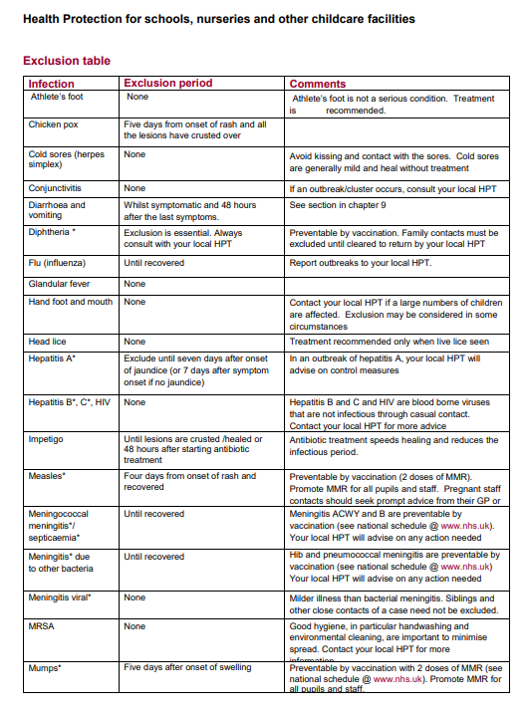

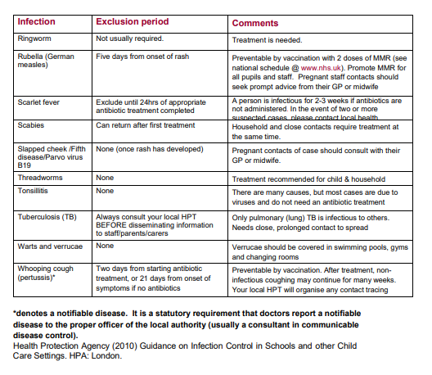

All the above information is kept in the Office.

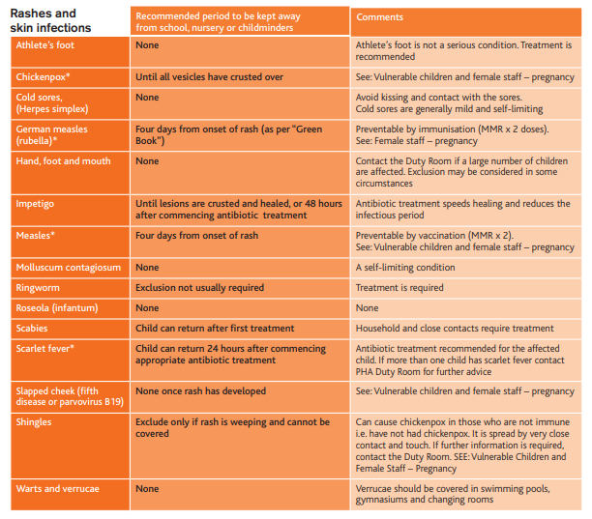

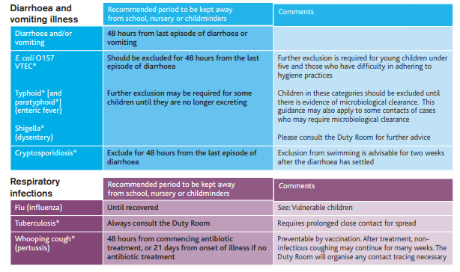

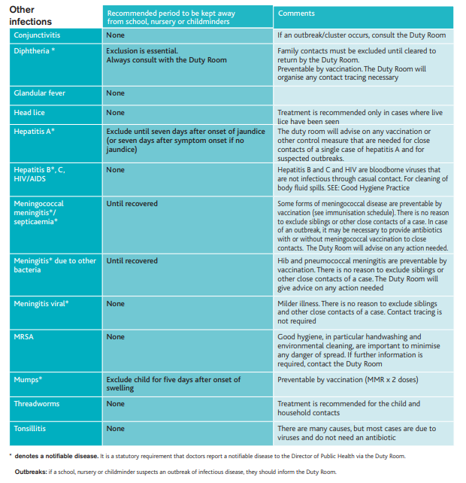
All the above information is kept in the Office.

Head Lice
Head lice information letters should then be sent out to the appropriate year group. These letters are kept in the office.
Parents are asked to inform the school asap if their child has head lice and these must be treated accordingly
Reporting Accidents
Employees
A) All non- notifiable accidents to employees must be recorded in the accident/ incident book, which is a controlled document and is kept in the health room. The school may also need to contact the Central Team for information.
Entries should be made in the presence of the injured person or their representative, where possible.

B) All notifiable accidents must be recorded in the same way, but the school also needs to contact the Central Team who will support with the necessary reporting requirements to outside bodies.

Notifiable accidents are:
a) The death of any person on the school site.
b) Any person suffering any of the following:
- Fracture of the skull, spine or pelvis.
- Fracture of any bone in the arm, wrist or ankle.
- Amputation of a hand, foot, finger, thumb or toe.
- Loss of sight or a chemical burn to an eye.
- Injuries including burns requiring immediate medical treatment or electric shock.
- Any injury resulting in the person being hospitalised for more than 24 hours.

Non-Employees and Pupils
All accidents to pupils, parents and other members of the public must be recorded in the accident book.
If any pupil sustains a severe injury following an accident an accident form must be filled in and forwarded to the Central Team who will support with the necessary reporting requirements to outside bodies.

Spillage and Bodily Fluids Policy
Introduction
Standard infection control precautions are a key component of infection prevention and control when dealing with the disposal of bodily fluids. They help protect staff and pupils by minimising the transmission of infection through bodily fluids.
The Code of Practice on the Prevention and Control of Infections and related guidance (the Health and Social Care Act 2008) states that “effective prevention and control of infection must be part of everyday practice and be applied consistently by everyone”.
Hand Hygiene
Hands play a major role in the transmission of infection. Effective hand hygiene is the single most effective method of preventing the spread of infection in school settings.
Hand hygiene is a term that incorporates the decontamination of the hands by methods including routine hand washing with soap and water and the use of hand rubs and gels.
*Hand hygiene should be encouraged by children after toileting and before handling/eating food and drink. This should also be modelled, where possible, by members of staff, lunchtime staff and all other adults within the school.
To try to prevent the spread of infection from colds and viruses, the use of tissues and coughing into tissues/hands should be encouraged, again with staff modelling this behaviour.
*Due to COVID 19, hand washing is expected and supervised at various points throughout the day in line with government guidance and risk assessments in place to prevent any further spread of the pandemic.

Safe Handling of Blood and Bodily Fluid Spillages
All blood or bodily fluids can potentially contain blood borne viruses or other pathogens, therefore dealing with spills of blood or body fluid may expose the staff member to these blood borne viruses or other pathogens.
Spillages of blood or bodily fluids must be decontaminated promptly; it is the responsibility of staff to deal with such spillages.
Spill kits are available in school.
Full Personal Protective Equipment (PPE), as set out in the schools’ risk assessments, must be worn as a minimum for cleaning spillage and disposed of in clinical waste containers (yellow containers).
The spillage should be soaked up with disposable paper towels.
For a minor spillage the surface should be cleaned with Spill Kit cleaning fluid. Sodium hypochlorite must not be used on urine spillage as this will result in toxic fumes.
Larger spillages of blood can be absorbed using chlorine-based granules sprinkled directly onto the spillage. Granules should be left for a contact time of 2 minutes (to inactivate any virus present).
Remove waste and dispose of in a clinical waste bag/container.
The area should then be cleaned with general purpose detergent and dried.
Hands should be washed thoroughly after the removal of PPE.
Urine spillages should be dealt with by washing the area with hot water and general-purpose detergent.

Cleaning and Decontamination of Equipment
Safe decontamination of equipment is an essential part of the routine infection prevention and control. It is the responsibility of each member of staff to ensure that re-useable equipment is decontaminated after use.
Equipment can act as a vehicle by which micro-organisms are transferred, which may result in infection. By cleaning and decontaminating equipment correctly, staff will reduce the risk to pupils and other staff
Items designated as single use must NOT be reused. Items designated as single person use must NOT be used more than once on a single patient.
Staff should have access at all times to the appropriate resources for cleaning, such as neutral detergent/disinfection wipes and chlorine releasing products.
Equipment must be cleaned in line with the manufacturers’ instructions in order to avoid damage.

Sharps Policy
Sharps Safety
Sharps devices, including blood glucose test pens and insulin pens, are routinely used as part of healthcare practice in school. As a school, we are aware of the risks posed by relevant contaminated sharps.
All staff are informed of the correct and safe procedures for the management of sharps. Staff are made aware of the action to take should a sharps injury occur, including the appropriate reporting of the incident.
Many sharps injuries can be avoided by adherence to the principles of safe sharps practice. However, it is recognised that injuries could be complete accidents. It is possible to reduce the risk of this happening by the use of safety procedure.
Sharps safety:
• Do not re-sheath used needles or sharps.
• Never pass sharps from person to person by hand – use a receptacle or clear field to place them in.
• Never walk around with sharps in your hand.
• Never leave sharps lying around – dispose of them.
• Dispose of sharps at the point of use – take a sharps bin with you.

Management of Sharps Injury
• If a sharps injury occurs, the following action must be taken IMMEDIATELY:
• Bleed it – encourage bleeding – but do not massage the site.
• Wash it – wash the injury, under hot running water.
• Report it – Inform Central Team and seek medical advice.

Data Protection
This policy adheres to the principles under data protection law, for further information please review the school's data protection policy published on the school's website.

