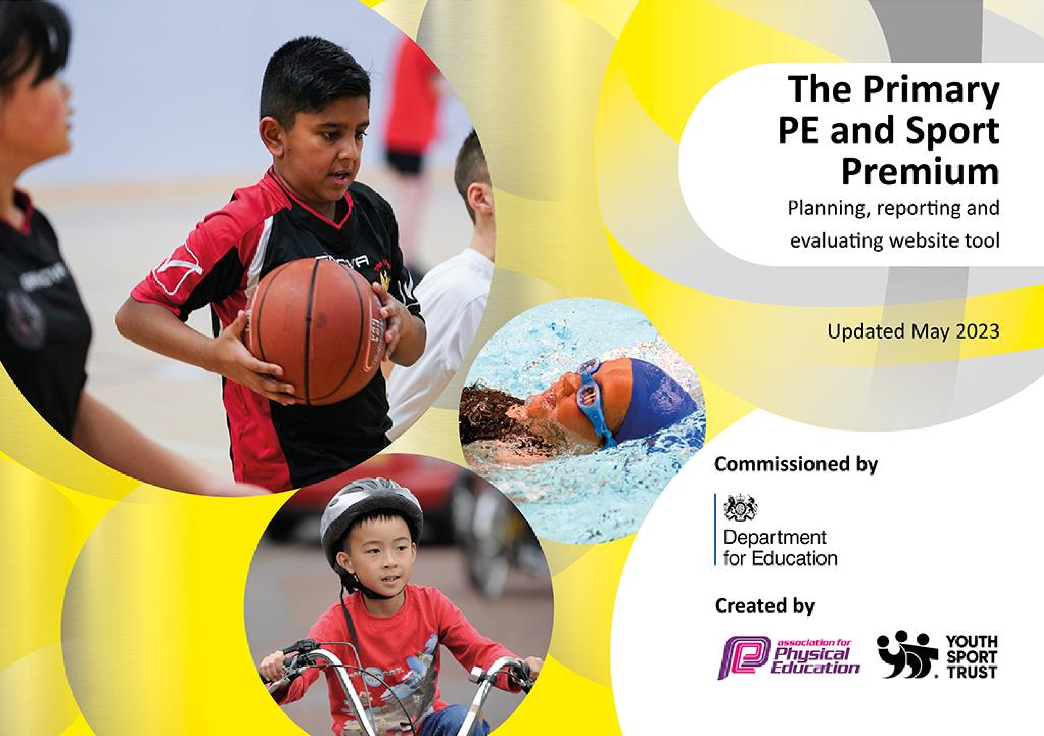
+

It is important that your grant is used effectively and based on school need. The Education Inspection Framework makes clear there will be a focus on ‘whether leaders and those responsible for governors all understand their respective roles and perform these in a way that enhances the effectiveness of the school’.

Under the Quality of Education Ofsted inspectors consider:
Intent - Curriculum design, coverage and appropriateness
Implementation - Curriculum delivery, Teaching (pedagogy) and Assessment Impact - Attainment and progress

To assist schools with common transferable language this template has been developed to utilise the same three headings which should make your plans easily transferable between working documents.

Schools must use the funding to make additional and sustainable improvements to the quality of Physical Education, School Sport and Physical Activity (PESSPA) they offer. This means that you should use the Primary PE and sport premium to:

- Develop or add to the PESSPA activities that your school already offer
- Build capacity and capability within the school to ensure that improvements made now will benefit pupils joining the school in future years
- The Primary PE and sport premium should not be used to fund capital spend projects; the school’s budget should fund these.

Please visit gov.uk for the revised DfE guidance including the5keyindicatorsacrosswhichschoolsshoulddemonstrate an improvement. This document will helpyoutoreviewyourprovisionandtoreportyourspend.DfEencouragesschools to use this template as an effective way of meeting the reporting requirements of the Primary PE and Sport Premium.

We recommend you start by reflecting on the impact of current provision and reviewing the previous spend.

Schools are required to publish details of how they spend this funding, including any under-spend from 2021/2022, as well as on the impact it has on pupils’ PE and sport participation and attainment. The funding should be spent by 31st July but the DfE has stated that there will be no clawback of any unspent money so this can be carried forward into 2023/24.

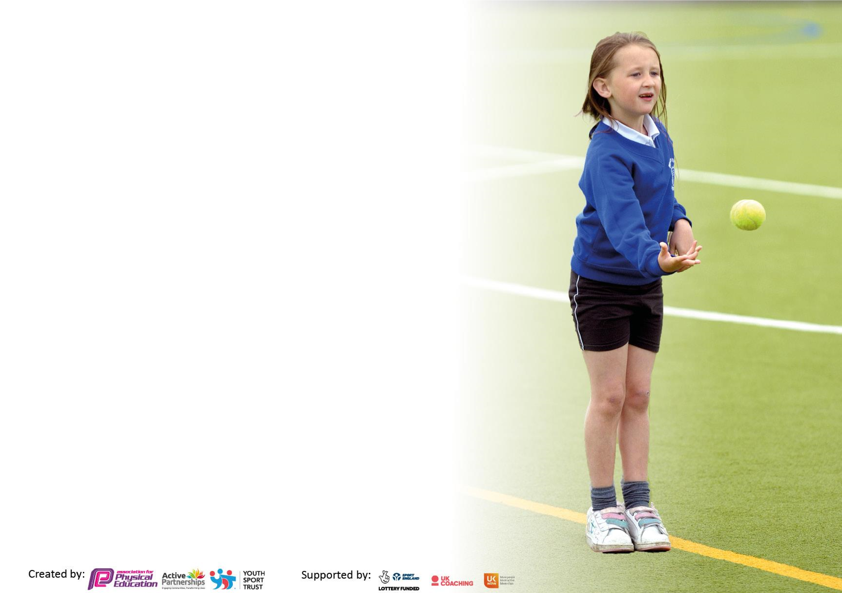
We recommend regularly updating the table and publishing it on your website throughout the year. This evidences your ongoing self-evaluation of how you are using the funding to secure maximum, sustainable impact. Final copy must be posted on your website by the end of the academic year and no later than the 31st July 2023. To see an example of how to complete the table please click HERE.

Details with regard to funding
Please complete the table below.

Total amount carried over from 2024/25 | £0
Total amount allocated for 2025/26 | £19,520
How much (if any) do you intend to carry over from this total fund into 2024/25? | £0
Total amount allocated for 2025/26 | £19,520
Total amount of funding for 2025/26 | £19,520

Swimming Data
Please report on your Swimming Data below.

Meeting national curriculum requirements for swimming and water safety.

N.B. Complete this section to your best ability. For example you might have practised safe self-rescue techniques on dry land which you can then transfer to the pool when school swimming restarts.
Due to exceptional circumstances priority should be given to ensuring that pupils can perform safe self rescue even if they do not fully meet the first two requirements of the NC programme of study
What percentage of your current Year 6 cohort swim competently, confidently and proficiently over a distance of at least 25 metres?  N.B. Even though your pupils may swim in another year please report on their attainment on leaving primary school at the end of the summer term 2024. Please see note above | 83%
What percentage of your current Year 6 cohort use a range of strokes effectively [for example, front crawl, backstroke and breaststroke]? Please see note above | 58%
What percentage of your current Year 6 cohort perform safe self-rescue in different water-based situations? | 58%
Schools can choose to use the Primary PE and sport premium to provide additional provision for swimming but this must be for activity over and above the national curriculum requirements. Have you used it in this way? | Yes/No  School will offer to current Year 6 pupils who did not learn to swim in Year 4 in the summer term.

Action Plan and Budget Tracking
Capture your intended annual spend against the 5 key indicators. Clarify the success criteria and evidence of impact that you intend to measure to evaluate for pupils today and for the future.

Key indicator 1: Increasing all staff’s confidence, knowledge and skills in teaching PE and sport |  |  |  | Percentage of total allocation:
 |  |  |  | 10.2
School focus with clarity on intended impact on pupils: | Actions to achieve: | Funding allocated: | Evidence and impact: | Sustainability and suggested next steps:
By the end of the academic year, all teaching staff will have received targeted professional development, including training in key indoor PE skills (gymnastics and dance), supported by specialist coaching or external partnerships where needed, and will demonstrate improved confidence and competence in delivering high-quality, inclusive PE lessons. | Invest in staff professional development for high-quality, inclusive PE teaching.  Provide specialist coaching or external partnerships where necessary.  Update equipment and facilities to enhance teaching and learning.  Staff training on specific key skills of indoor PE e.g. gymnastics and dance, identified through self-evaluation tools, so that teachers have the confidence and level of expertise to teach all areas of PE effectively and confidently.  Source appropriate training for staff internally, including peer coaching/within the Trust/from outside agencies, as required.  Make use of online digital portals to measure PE attainment, in addition to gaining  access to quality CPD courses (either online or in person). | £2000 | Pre- and post-training surveys or self-evaluation forms showing increased confidence in teaching all areas of PE, particularly gymnastics and dance.  Lesson observations indicating improved teaching quality and use of inclusive practices.  Lesson plans reflecting a wider range of activities, including previously under-taught indoor PE skills.  Evidence of differentiated approaches to ensure all pupils, including those with additional needs, can participate effectively.  Feedback from pupils indicating enjoyment, engagement, and confidence in PE lessons.  Assessment data showing progression in skill acquisition across all areas of PE. | Staff complete an audit of own skills through self-evaluation as baseline and review following the training.  Key staff identified as ‘experts’ in different aspects of PE skills so that they can support less confident teachers/teachers new to teaching throughout the next academic year.  Ensure an efficient and  manageable assessment of  pupils’ PE skills in place that identifies areas for development to enable target teaching.

Key indicator 2: Increasing engagement of all pupils in regular physical activity and sport |  |  |  | Percentage of total allocation:
 |  |  |  | 37.6
Intent | Implementation |  | Impact
School focus with clarity on intended impact on pupils: | Actions to achieve: | Funding allocated: | Evidence and impact: | Sustainability and suggested next steps:
To increase pupil engagement in physical activity at lunchtimes, develop competence in a broad range of sports, and ensure disadvantaged pupils have regular access to quality play opportunities. | Professional Sports Coach Support:  Reutilise professional Sports Coach expertise to model a variety of sporting activities during lunchtimes.  Coaches will demonstrate activities for key staff and upper KS2 Play Leaders to implement independently.  Lunchtime Supervisor and Play Leader Development  Train lunchtime supervisors and upper KS2 pupils to confidently lead playground activities in the absence of coaches.  Develop a rota to ensure all children, particularly disadvantaged pupils, have regular opportunities to participate.  Begin skill development for lower KS2 pupils to prepare them to take on play leader roles in future years.  Senior leader implement expectations of what ‘excellence’ looks like in playground interactions including developing non-equipment playground games.  Playground Improvements  Implement ‘zoned’ playground areas and purchase additional equipment to ensure quality sports provision.  Add playground markings (e.g., netball court) to support structured PE games and activities.  Pupil Voice and Engagement  Senior leaders to liaise with the school council to gather pupil input on preferred activities.  Regularly conduct pupil voice surveys to ensure activities meet interests and needs. | £3740  £1000 | Regular lunchtime audits and pupil voice will demonstrate an increase in number of children, particularly disadvantaged children, who participate in physical activity at lunchtime, and being able to talk about the games/new skills they are learning.  Lunchtime supervisors and Play leaders will be confident in articulating the rules for their games and able to lead other pupils in game play.  Pupils will be confident and develop competence in using the appropriate equipment correctly for the various games. This will be evidenced through pupil voice  and lunchtimes observations.  Identify how active pupils are through online pupil questionnaires, one taken at the  start of the academic year, and one taken at the end of the academic year – allowing  for comparison. | Key lunchtime supervisors to be identified to support physical activity at lunchtime and pass on skills to new joiners in addition to leading activities at lunchtime in the absence of Sports Coaches.  Begin to develop skills of lower KS2 pupils so they can adopt the roles at lunchtime as older children leave for secondary.  Continue to develop non-equipment playground games.
To increase daily physical activity for all pupils while promoting fitness, health, and social interaction. | All pupils to take part in a ‘walk and talk’ at the end of lunchtimes run by lunchtime staff and coach to increase daily physical activity and promote fitness and health.  At the end of lunchtimes, all pupils will participate in walking/jogging for up to 10 minutes. | £0 | Based on the principles of the daily mile- this walking is fully inclusive, and all pupils will be taking part in an additional 15 minutes of exercise per day. Pupils will be fitter, and healthier.  Through pupil voice, pupils will share a sense of achievement and accomplishment each day. | During the Summer months,  pupils will utilise the larger field areas.  Pupils will build up to walking/jogging a mile each day.
To ensure all Year 6 pupils meet the national curriculum expectation of being able to swim at least 25 metres by the end of Key Stage 2. | Identify children that need further teaching and practice. Organise swimming sessions Spring/Summer  2026 at Gig Mill pool | £2600 | An increase in current Year 6 children who can swim at least 25m from 83% to >95% | Continue swimming in Jan 2026 for those children moving into Year 5 who cannot yet swim 25m.

Key indicator 3: Raising the profile of PE and sport across the school, to support whole school improvement |  |  |  | Percentage of total allocation:
 |  |  |  | 0.03
Intent | Implementation |  | Impact
School focus with clarity on intended impact on pupils: | Actions to achieve: | Funding allocated: | Evidence and impact: | Sustainability and suggested next steps:
Linked to the school’s Character Development Plan and Skills Builder framework, pupils will develop an understanding of the importance of sports science alongside the key qualities of being an athlete. Through PE and enrichment opportunities, pupils will build resilience, discipline, teamwork, and self-awareness, supporting both their physical development and broader life skills. | Introduction to Sports Science, Pupils learn how nutrition, hydration, recovery, and fitness affect performance through healthy eating workshops, RSHE and science curriculum.  Invite local athletes or sports professionals to talk about their journey and life lessons.  Skills Builder to focus, in relation to competitive sport on ‘staying positive’, ‘aiming high’,  ‘leadership’ and ‘teamwork’ so that talented children build their mental and emotional skills as well as physical. | £500 | Pupils demonstrate increased understanding of sports science concepts (e.g., fitness, nutrition, recovery) through class discussions, quizzes, or project work.  Observable improvements in pupils’ resilience, teamwork, leadership, and self-management skills during PE lessons and enrichment activities.  Pupil voice surveys indicate enhanced confidence, motivation, and awareness of how physical activity supports wellbeing and character growth. | Lesson plans and schemes of work include explicit references to character traits and life skills (e.g., resilience, communication, problem-solving).

Key indicator 4: Offer a broader and more equal experience of a range of sports and physical activities to all pupils |  |  |  | Percentage of total allocation:
 |  |  |  | 31.7
Intent | Implementation |  | Impact
All pupils will have equitable access to a broad range of after-school sports clubs, including competitive teams. Participation will increase overall engagement in physical activity, enhance teamwork, and develop confidence, with measurable improvements in pupils’ physical skills and inter-school competition involvement. | Staff to deliver after-school sports clubs to broaden enrichment opportunities for all students, with a particular focus on engaging Pupil Premium students. These clubs include competitive sports teams that allow pupils to participate in inter-school competitions, promoting physical development, and teamwork. | £3000 | Increased participation from all pupils actively engaging in extracurricular sports, reducing barriers to participation.  Pupils show improved physical fitness, teamwork, communication, and leadership skills.  Confidence and wellbeing: Feedback indicates higher self-esteem and motivation among all pupils.  Withymoor Primary School to win several inter school competitive events, and showcase the sportsmanship and skills shown by the pupils. | Increase participation in inter-school competitions, to build confidence and resilience.  Introduce termly evaluation surveys for pupils and parents to assess enjoyment, progress, and barriers to participation.  Allocate resources to purchase necessary equipment and kits to remove financial barriers for disadvantaged pupils.

All Reception children will participate in Forest School sessions led by an external Forest School Lead, developing social skills, teamwork, confidence, and an appreciation for outdoor learning. Children will demonstrate improved collaboration, communication, and engagement in practical, hands-on activities. | Forest School offered for Reception children led by outside Forest School Lead to enable children to experience outdoor, fun activities, whilst learning social and team work skills.  Forest School arranged for Spring term 2026 once a week – all Reception children to participate | £2680 | Children, particularly disadvantaged, have the opportunity explore the outdoors, improve their physical health, increase creativity, reduce their stress levels and enhance their cognitive learning.  Evidence of children applying teamwork and problem-solving skills in other classroom or outdoor contexts. | Gather pupil voice as a baseline and following the sessions to measure progress of skills, enjoyment and confidence in the sessions.
SEND pupils will participate in regular, inclusive sports sessions supported by a volunteer from the local Football Association. This will promote inclusion, physical engagement, teamwork, and confidence among SEND pupils. Pupils will develop key physical coordination, communication, and social interaction skills through structured, accessible sporting experiences. | Collaboration with the local Football Association volunteer has enhanced staff knowledge of inclusive coaching techniques. | £0 | Attendance logs show regular participation of SEND pupils in inclusive sports sessions.  Increased pupil engagement, enthusiasm, and willingness to participate in physical activity observed during sessions. | Continue partnership with the local Football Association to maintain regular inclusive sessions.  Explore opportunities for SEND pupils to participate in local or inter-school inclusive sports events.  Lesson and session plans demonstrate appropriate differentiation and adapted activities to meet individual needs.
Key indicator 5: Increase participation in competitive sport |  |  |  | Percentage of total allocation:
 |  |  |  | 10.2
School focus with clarity on intended impact on pupils: | Actions to achieve: | Funding allocated: | Evidence and impact: | Sustainability and suggested next steps:
Introduce a house team system enabling all pupils to participate in regular intra-school competitions, fostering teamwork, school pride, and healthy competition. | Assign all pupils to one of the new houses, ensuring balanced distribution of Pupil Premium pupils, pupils with EAL and SEND.  Decide on house colours, logos, and identity to create excitement and engagement.  Develop an annual calendar of house competitions, including a mix of individual and team sports.  Launch house teams with a whole-school assembly to explain the system and promote pride.  Appoint house captains and vice-captains, including targeted Pupil Premium pupils, to foster leadership.  Encourage older pupils to mentor younger pupils during competitions. | £1000 | All pupils actively participate in intra-school competitions, raising overall attendance at sports activities.  Pupils develop skills such as collaboration, communication, and leadership through house roles and competitions.  House competitions foster a sense of identity, camaraderie, and healthy competition across all year groups.  Students report higher confidence and enjoyment in PE and sports-related activities.  Participation in house competitions has positive effects on punctuality, attendance, and wider school engagement.  House points system and celebrations promote sustained participation and reward effort and progress. | Hold termly awards or assemblies celebrating house points and outstanding effort.  Publish house competition results in newsletters, on displays, and via social media to increase motivation.

Participate in inter-school tournaments/sports activities, where available to showcase skills and confidence in pupils. | PE lead to pro-actively engage with other schools for competitions.  PE lessons/after school and lunchtime clubs to include more competitive sports in order to identify and nurture talent. | £1000 | All pupils will have equal access to inter-school competitions, promoting ambition and resilience.  Engagement with school: Participation in sports clubs will lead to better attendance and punctuality for targeted pupils.  Pupils with a talent in particular sports are identified and supported to reach their full potential.  Culture in school developed so that children have passion and motivation to win, but also the skills of resilience, team spirit and positivity, which are three of our school values.  PE and Sports Premium coordinator to monitor and track children’s participation in sporting activities, during and after school (including weekend clubs), particularly those disadvantaged or SEND to provide clear analysis of the uptake to further develop opportunities for disadvantaged/SEND pupils. | To continue to build inter school tournaments that become a regular fixture for the school.

Signed off by
Head Teacher: | L.Smith
Date: | October 2025
Subject Leader: | L. Knowles
Date: | October 2025
Governor:
Date:

