


Weekly round up!
This term, I have met with teachers to hold pupil progress meetings. These meetings allowed us to review the latest assessments and set clear targets to support children’s learning in the coming term. We are really pleased to see the many positive steps pupils are making in both their confidence and achievement.

This week, w e have also welcomed visitors from our Trust School Improvement team, including leads for English and SEND. They shared very positive feedback about the progress pupils have made, as well as the clear routines, support systems and high -quality teaching seen across the school.
We are particularly proud of the improvements in behaviour across the school. This reflects the hard work and consistency of staff in following our behaviour pathway and setting high expectations for all pupils. Thank you to our children for responding so positively, and to our staff for their continued dedication.
As always, thank you to parents and carers for your ongoing support - working together truly makes a difference for our children.

Assembly Values
In assembly this week, we focused on British values and learned about St George, the patron saint of England. We explored some of the traditional stories associated with him, including the well-known legend of St George and the dragon.
We also found it interesting to learn that St George was likely a Roman soldier, and how the image of him in a crusader-style uniform has become part of the symbolism of the English flag.
As part of our discussion, we thought about the values St George represents, such as bravery and standing up for what is right, and how these link to the British values we learn about today. Children were encouraged to reflect on how they can show bravery in their own lives, whether that’s trying something new, speaking up, or helping others. It gave everyone a chance to reflect on values we can all demonstrate every day.

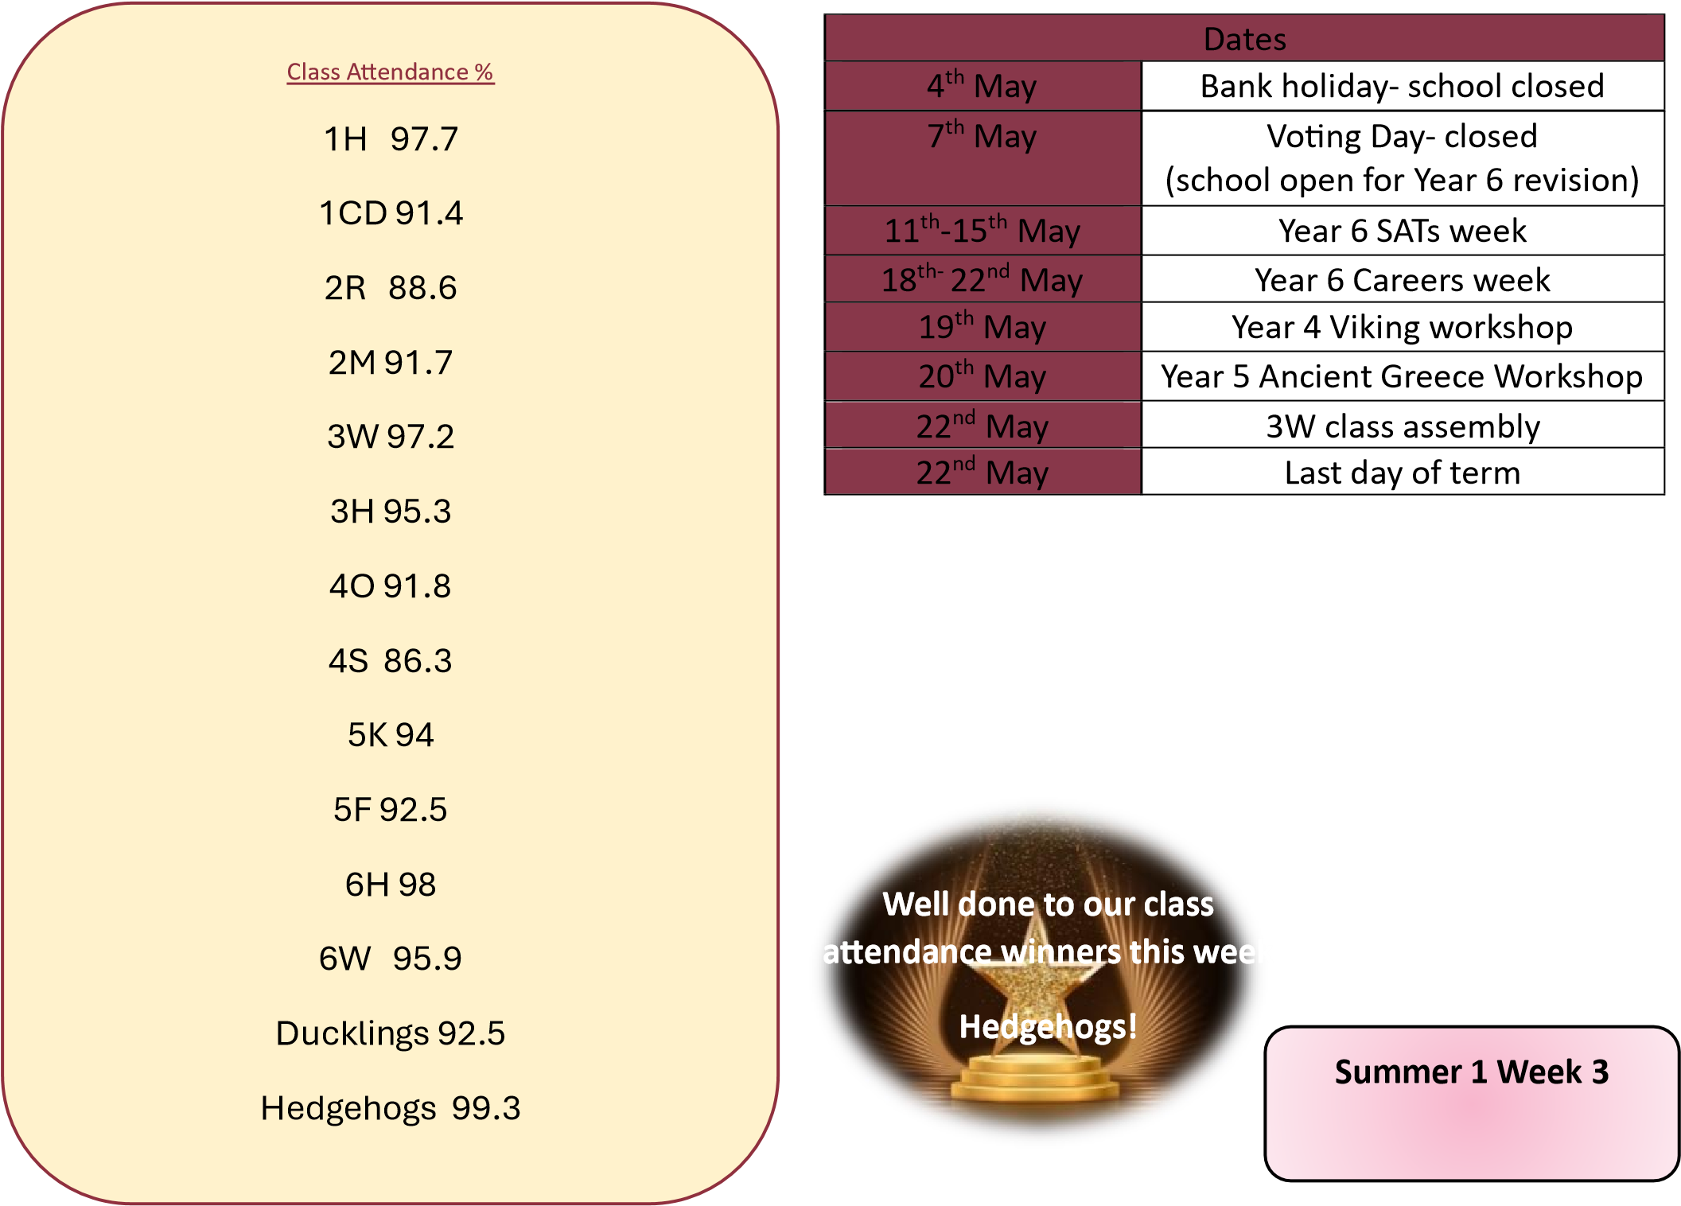

Re
view meeting
s

This week we hel
d

our SEND review meetings with parents
and carers. These meetings are for pupils who have been
identified as having special educational needs
.

In addition
to parents’ evening, these meetings give us the chance to
talk in more detail about individual targets and the support
in place for your child. They are a valuable opportunity to
work together and ensure we are meeting each pupil’s
needs effect
ively.

Thank you to everyone who was able to attend

and for
cont
inuing to
support

your child
’s
learning

at home
-

we
really appreciate your time and input.

If you were unable to attend, you will receive a copy of your
child’s Assess, Plan, Do, Review (APDR) from the class
teacher.

