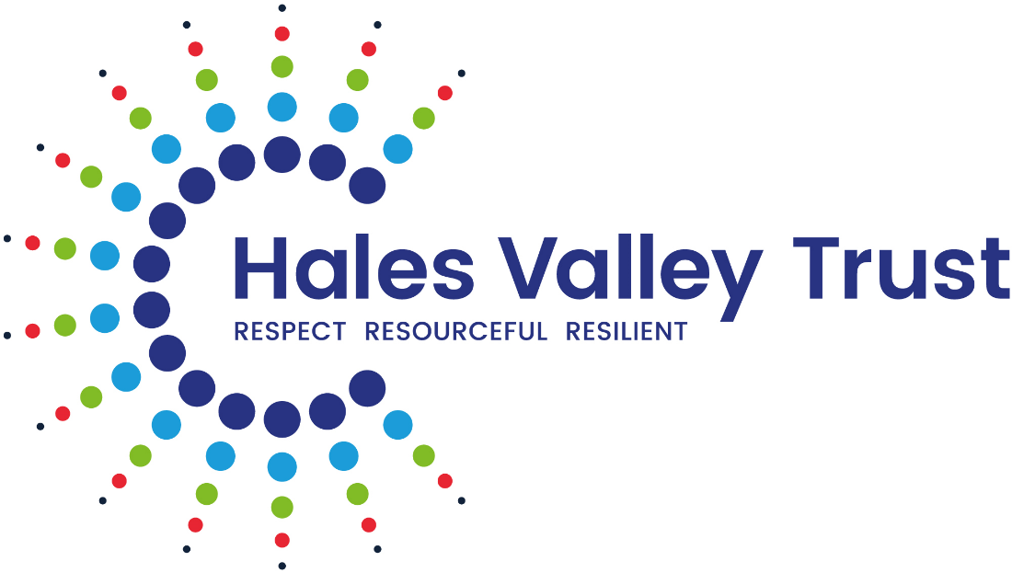

Anti-Bullying and Prejudice-Related Incident Policy

Policy Tracker – Responsibility for monitoring this policy:
(Reviewed annually – date of next review)
Date of review | Reviewed By: | Role | Date Approved by Board of Trustees
July 2026 | Kate Hall | Director of Education | July 2026

Contents
- Purpose and Aims …………………………………………………………………………………………….3
- Legal Framework ………………………………………………………………………………………………3
- Links to Other Policies and Guidance …………………………………………………………………..4
- Definitions ……………………………………………………………………………………………………….4
4.1 Bullying
4.2 Prejudice-Related Incidents
4.3 Hate Incidents and Hate Crime
4.4 Cyberbullying
- Protected Characteristics……………………………………………………………………………………6
- Roles and Responsibilities ………………………………………………………………………………….7
- Prevention, Education and School Culture …………………………………………….……………10
7.1 Promoting Equality, Diversity and Inclusion
7.2 Curriculum and Prevention
7.3 Staff Training
7.4 Pupil Voice and Participation
- Reporting Concerns …………………………………………………………………………………………12
- Responding to Bullying and Prejudice-Related Incidents ……………………………………….14
9.1 Initial Response
9.2 Investigation
9.3 Outcomes and Actions
9.4 Restorative Approaches
9.5 Sanctions
- Support for Those Involved ……………………………………………………………………………….16
10.1 Support for Victims
10.2 Support for Pupils Responsible for Incidents
10.3 Support for Bystanders and Wider Groups
- Working with Parents and External Agencies ……………………………………………………….17
- Recording and Monitoring …………………………………………………………………………………18
- Links with Safeguarding ……………………………………………………………………………………21
- Monitoring, Evaluation and Review …………………………………………………………………….24
Appendices
Appendix A: Definitions and Examples of Bullying ……………………………………………………………25
Appendix B: Examples of Prejudice-Related Language and Behaviour ………………………………..26
Appendix C: Examples of Hate Incidents and Hate Crimes ……………………………………………….27
Appendix D: How Our School Values Support Equality and Inclusion …………………………………28
Appendix E: Incident Response Flowchart ……………………………………………………………………..35
Appendix F: Recording and Monitoring Guidance ……………………………………………………………36
Appendix G: Useful Contacts and Support Organisations …………………………………………………37
Appendix H: Relevant Legislation and DfE Guidance ……………………………………………………….41
1. Purpose and Aims
At Hales Valley Trust, we are committed to providing safe, inclusive and respectful environments where every pupil feels valued and has a strong sense of belonging. We believe that all members of our school communities have the right to feel protected, respected and able to thrive.
Bullying and prejudice-related incidents of any kind are unacceptable and will not be tolerated. We recognise that such behaviours can have a significant impact on pupils’ wellbeing, attendance and ability to learn, and can affect the wider school community. Therefore, we take a proactive and preventative approach, alongside clear and consistent procedures for responding when concerns arise.
This policy underpins our commitment to:
- Promoting equality, diversity and inclusion across all areas of school life
- Fostering positive relationships built on respect, empathy and understanding
- Creating a culture where kindness, inclusion and mutual respect are actively taught and modelled
- Ensuring that all members of the school community understand their role in preventing and addressing bullying and prejudice-related behaviour

Within Hales Valley Trust schools, all incidents are:
- treated with the utmost seriousness
- recorded and investigated in line with school procedures
- responded to promptly and consistently
- addressed with a focus on safeguarding, support and education
Where necessary, the school will work in partnership with external agencies, including the Local Authority and, where appropriate, the police.
All incidents, regardless of severity, are addressed proactively to:
- protect those affected
- challenge discriminatory behaviour
- promote an inclusive culture where diversity is respected
This approach ensures that all members of the school community feel safe, valued and supported, and that discrimination in all forms is actively challenged.

2. Legal Framework
This policy has due regard to statutory legislation, including but not limited to, the following:
- The Education and Inspections Act 2006
- The Equality Act 2010
- DfE guidance: Preventing and Tackling Bullying 2017
- Keeping Children Safe in Education 2026
- DfE Behaviour in Schools 2024
- Prevent Duty Guidance: for England and Wales 2023

3. Links to Other Policies and Guidance
- Equality Information and Objectives
- Behaviour Policy
- Safeguarding and Child Protection Policy
- SEND Policy
- Online Safety Policy
- Staff Code of Conduct
4. Definitions
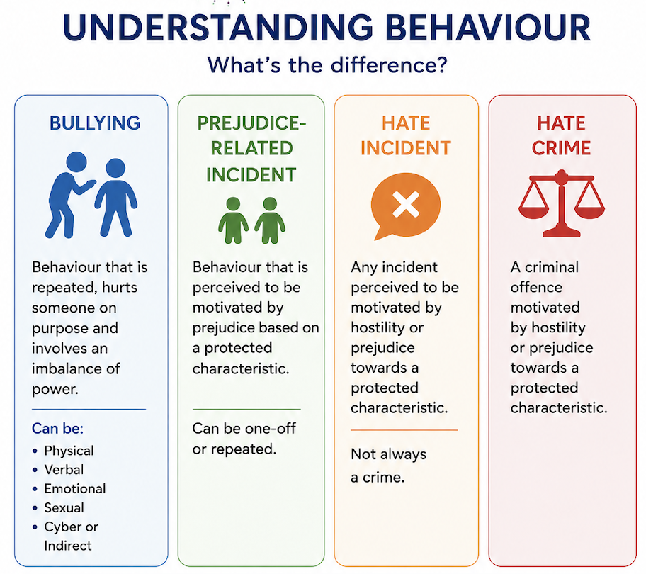
4.1 Bullying
Bullying is defined as behaviour by an individual or group, repeated over time, that intentionally hurts another individual or group physically or emotionally, often involving an imbalance of power. This can include situations where the person being bullied feels unable to defend themselves. Bullying can take place face-to-face or through digital platforms. This definition reflects key elements identified by the Anti-Bullying Alliance and the Department for Education (2017).

Bullying behaviour can take many forms, including:
- Physical: pushing, kicking, hitting, biting or any use of force
- Verbal: name-calling, teasing, threats, sarcasm or spreading rumours
- Emotional/Psychological: exclusion, intimidation, humiliation, manipulation or coercion
- Sexual: unwanted physical contact, inappropriate comments or exposure to harmful content
- Online/Cyber: abusive messages, sharing images, social exclusion or online harassment
- Indirect: exploiting individuals or encouraging others to engage in bullying behaviour
4.2 Prejudice-Related Incidents
A prejudice-related incident is any incident which is perceived, by the victim or any other person, to be motivated by prejudice or discrimination based on a person’s protected characteristics: age, disability, gender reassignment, marriage and civil partnerships, pregnancy and maternity, race, religion or belief, sex, sexual orientation.
Such incidents may not always be repeated or involve a power imbalance (and therefore may not meet the definition of bullying), but they are still taken seriously. They can include derogatory language, stereotyping, exclusion, harassment or any behaviour that causes offence or harm based on prejudice.
All reported incidents will be recorded, investigated and addressed appropriately to promote an inclusive and respectful environment - promoting a positive
4.3 Hate Incidents and Hate Crime
A hate incident is any incident which is perceived, by the victim or any other person, to be motivated by hostility or prejudice towards a person’s protected characteristics. These characteristics include disability, race, religion or belief, sexual orientation and transgender identity. Hate incidents can take many forms, including verbal abuse, name-calling, derogatory language, threatening behaviour, exclusion or online abuse.
A hate incident does not necessarily constitute a criminal offence; however, all such incidents are taken seriously due to their potential impact on an individual’s wellbeing, sense of safety and belonging.
A hate crime is a criminal offence that is motivated, either wholly or in part, by hostility or prejudice towards a person’s protected characteristics. This may include offences such as physical assault, harassment, criminal damage or online abuse where there is evidence of prejudice or bias.
4.4 Cyber-Bullying
Cyberbullying is a form of bullying that takes place online or through digital technologies. It involves the intentional and repeated use of electronic communication - such as social media, messaging apps, gaming platforms or mobile devices - to harm, upset, intimidate or humiliate another individual.
This behaviour may include sending threatening or hurtful messages, sharing images or information without consent, excluding individuals from online groups, or creating content intended to damage a person’s reputation. Cyberbullying can occur at any time and place and may have a significant impact on a child’s emotional wellbeing and safety.
5. Protected Characteristics
At Hales Valley Trust, we recognise the importance of ensuring that all individuals are treated fairly, with dignity and respect, regardless of their background, identity or personal characteristics.
We promote an age-appropriate understanding of equality, diversity and inclusion, ensuring that pupils recognise and value the rich diversity within our school communities and wider society. Through this, pupils develop the knowledge and confidence to challenge stereotypes, recognise unfairness and stand up against discrimination.
The Equality Act 2010 identifies the following protected characteristics:
- Age
- Disability
- Gender reassignment
- Marriage and civil partnership
- Pregnancy and maternity
- Race
- Religion or belief
- Sex
- Sexual orientation

These characteristics provide a framework for identifying and responding to prejudice-related incidents, ensuring that all concerns are addressed appropriately and consistently.
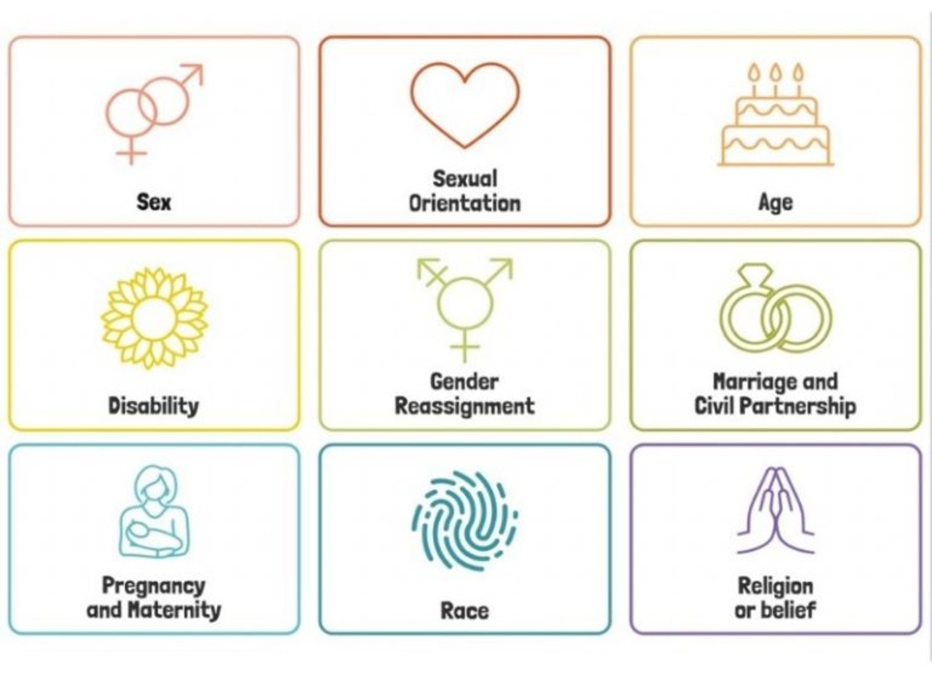

6. Roles and Responsibilities
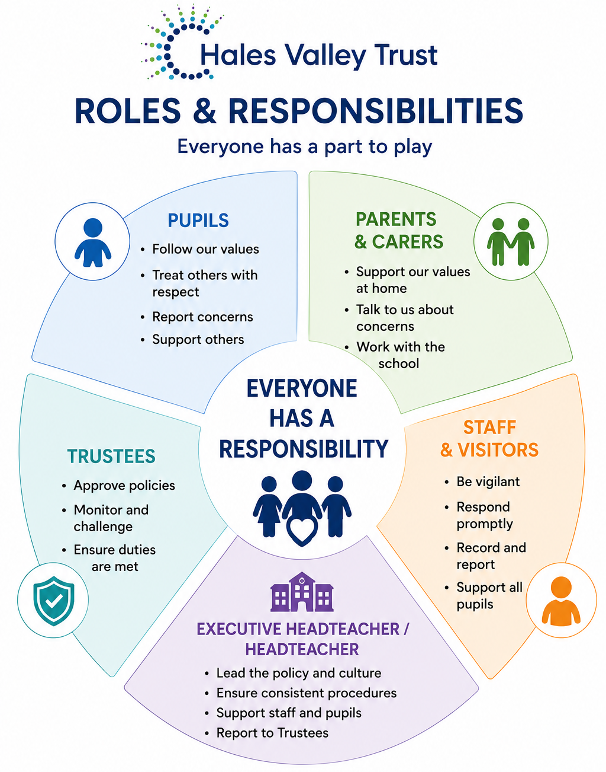
At Hales Valley Trust everyone is responsible for promoting and challenging bullying and prejudice-related incidents.
Pupils will:
- follow the Hales Valley Trust and their own school values and expectations
- learn to understand what bullying and prejudice-related behaviours are
- report bullying and prejudice-related incidents to a trusted adult
- support peers
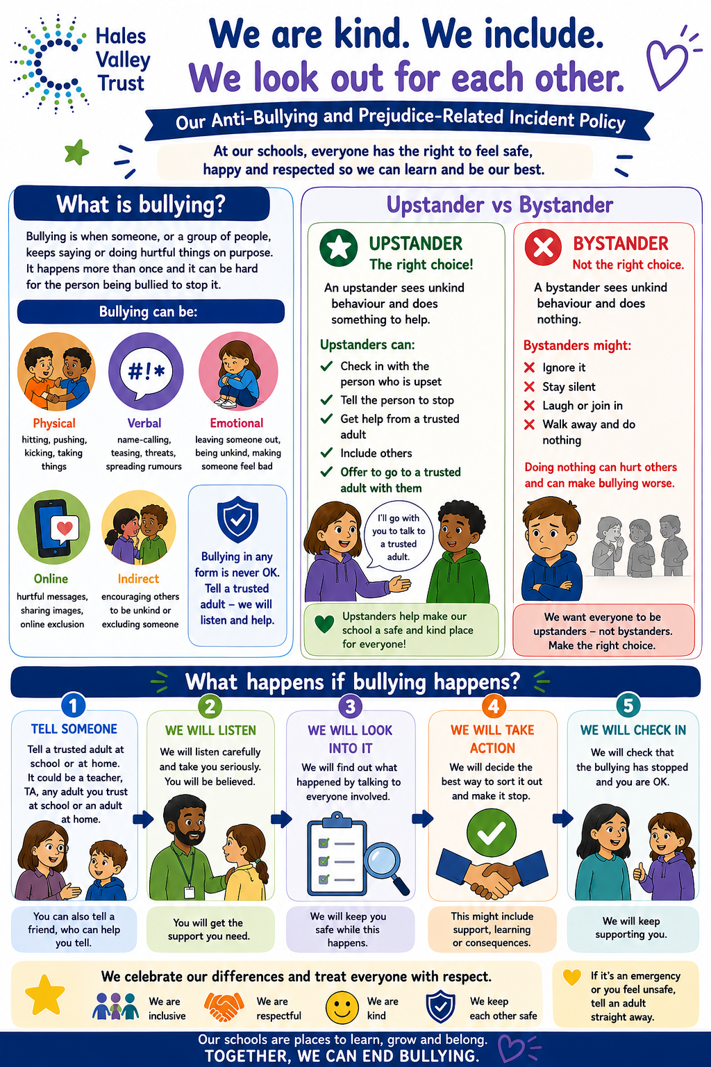

Parents/Carers will:
- support the school’s values and policies, reinforcing positive behaviour, respect and inclusion at home.
- encourage open communication, ensuring their child feels able to talk about any concerns related to bullying or prejudice.
- report concerns promptly to the school if they believe their child is experiencing or involved in bullying or prejudice-related incidents.
- work in partnership with the school, cooperating with staff and/or visitor to address incidents and support appropriate resolutions.
- help their child understand the impact of their behaviour, promoting empathy, kindness and respect for others.
- support strategies and interventions put in place by the school, including restorative approaches where appropriate.
- monitor their child’s online activity, helping to ensure safe and responsible use of technology and social media.

All staff, including visitors will:
- promote a whole-school culture of respect and inclusion, where diversity is celebrated, discrimination is actively challenged and a sense of belonging is fostered.
- be vigilant and proactive, recognising signs of bullying or prejudice-related behaviour, including less obvious or indirect forms.
- take all concerns seriously, listening carefully to pupils and/or staff/visitors and responding promptly, sensitively and appropriately.
- record and report incidents in line with school procedures, ensuring accurate documentation of bullying and prejudice-related incidents.
- investigate incidents fairly and consistently, ensuring that all parties are heard and that appropriate action is taken.
- support pupils involved, including those who have experienced bullying or prejudice, those displaying the behaviour and any bystanders, using restorative and educative approaches where appropriate.
- work in partnership with parents/carers and external agencies when necessary to support pupils and address concerns effectively.
- educate pupils through the curriculum and wider school opportunities about respect, diversity and the impact of bullying and prejudice.
- safeguard all pupils’ and all staff wellbeing, ensuring that incidents are addressed in a way that prioritises safety, support and inclusion.

Executive Headteacher will:
- provide clear leadership and direction in the implementation of the school’s anti-bullying and prejudice-related incidents policy.
- ensure effective procedures are in place for preventing, identifying, recording and responding to bullying and prejudice-related incidents.
- promote a whole-school culture of respect and inclusion, where diversity is celebrated, discrimination is actively challenged and a sense of belonging is fostered.
- monitor and review incidents, ensuring that appropriate actions are taken and that patterns or trends are identified and addressed.
- support and guide staff, ensuring they are trained, confident and consistent in dealing with incidents.
- communicate with parents/carers and where necessary, external agencies, particularly in more serious or persistent cases.
- ensure statutory duties are met, including safeguarding responsibilities and adherence to equality legislation.
- report to trustees, providing updates on incidents and the effectiveness of the school’s strategies.

Trustees will:
- ensure robust policies are in place, including those related to anti-bullying and prejudicial behaviour, safeguarding and equality and that these are regularly reviewed and compliant with statutory requirements.
- hold the Executive Headteacher to account for the effective implementation of these policies and for the school’s response to bullying and prejudice-related incidents.
- monitor the effectiveness of the school’s approach, including reviewing data and reports on incidents to ensure appropriate action is taken and patterns are identified.
- promote a culture of inclusion and equality, ensuring that diversity is respected and that discrimination is challenged across the school community.
- support safeguarding responsibilities, ensuring that pupil, staff and visitors wellbeing and safety are prioritised at all times.

7. Prevention, Education and School Culture
7.1 Promoting Equality, Diversity and Inclusion
At Hales Valley Trust, promoting equality, diversity and inclusion is central to our ethos. We actively challenge discrimination and promote a culture where diversity is celebrated, and all individuals are treated with dignity and respect.
Our shared values of being respectful, resourceful and resilient underpin our approach, supporting pupils to develop empathy, understanding and a strong sense of social responsibility.
7.2 Curriculum and Prevention
Preventative education is embedded across all areas of school life. Pupils learn about respectful relationships, equality and inclusion through:
- The PSHE/RSHE curriculum
- Assemblies and themed curriculum opportunities
- Exploration of diverse texts and experiences
- Daily interactions and modelling by staff

This supports pupils in developing an understanding of British Values and the principles of fairness, equality and mutual respect, preparing them to contribute positively to a diverse society.
7.3 Staff Training
All staff play a vital role in promoting an inclusive culture. Staff are supported through training and guidance to:
- Recognise and respond effectively to bullying and prejudice-related behaviour
- Promote inclusive practice and challenge discrimination
- Understand safeguarding responsibilities linked to these behaviours

This ensures a consistent, informed and confident approach across all schools within the Trust.
7.4 Pupil Voice and Participation
We recognise the importance of pupil voice in shaping a positive and inclusive school culture. Pupils are encouraged to:
- Share their views and experiences
- Contribute to discussions about equality and inclusion
- Take an active role in promoting respect and challenging prejudice

This empowers pupils to understand their rights and responsibilities and to contribute positively to their school community.
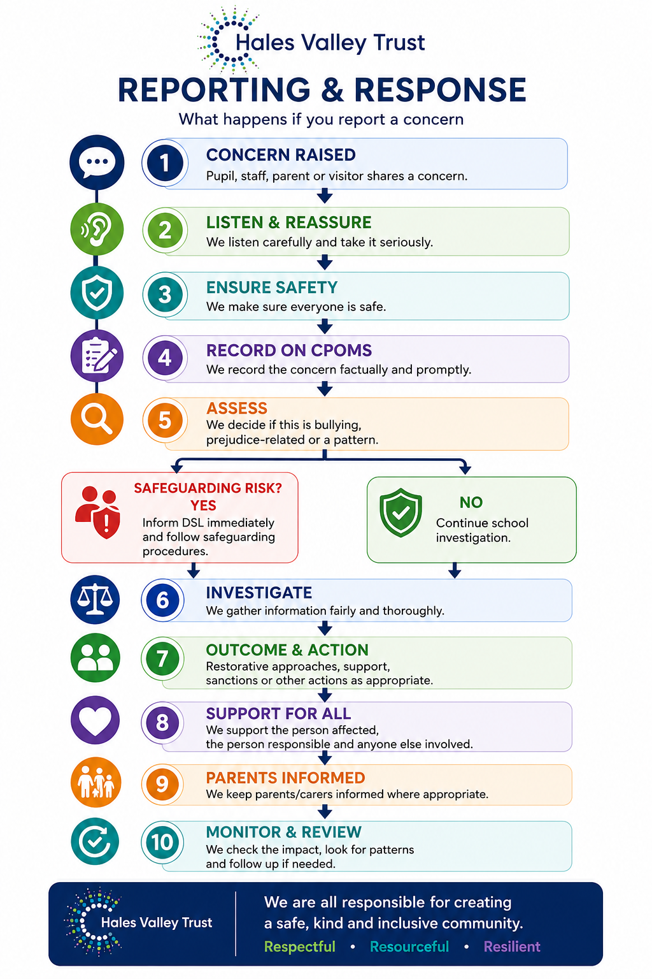
8. Reporting Concerns
At Hales Valley Trust, we promote a culture where everyone feels safe, confident and empowered to speak up. All stakeholders are encouraged to report any concerns about bullying or prejudice-related behaviour at the earliest opportunity, knowing that they will be taken seriously and supported appropriately.
How pupils report concerns
Pupils may report concerns in a range of ways, including:
- speaking to a trusted adult (e.g. class teacher, teaching assistant, DSL or senior leader)
- using agreed school systems such as worry boxes or pupil voice opportunities
- reporting concerns on behalf of a friend or peer

All reports are handled sensitively, ensuring pupils feel listened to, reassured and safe, while also understanding that some information may need to be shared to keep them protected.
How staff report concerns
All staff have a duty to respond promptly and appropriately to concerns. Staff will take all reports seriously and act immediately to ensure everyone is supported.
Staff responsibilities include:
- listening carefully and responding sensitively to concerns raised
- recording incidents promptly, factually and accurately on CPOMS
- informing the Designated Safeguarding Lead (DSL) or senior leaders where appropriate
- following up to ensure that appropriate action has been taken

This consistent approach ensures that concerns are not overlooked and that all incidents are tracked effectively.
Parent/carer concerns
We recognise the importance of strong partnership working with parents and carers. They are encouraged to raise concerns as soon as possible so that issues can be addressed early.
Typically, parents/carers should:
- contact the class teacher in the first instance
- escalate to a senior leader where concerns remain

All concerns will be acknowledged and investigated thoroughly. Schools will maintain clear communication, ensuring parents feel reassured that concerns are being taken seriously and addressed appropriately, while maintaining confidentiality for all pupils involved.
Anonymous reporting
Where appropriate, schools may provide opportunities for anonymous reporting. This can support individuals who may not yet feel confident sharing concerns directly.
- All anonymous reports will be considered carefully
- However, action may be limited where insufficient detail is provided
Staff will use professional judgement to determine appropriate next steps, including monitoring or preventative work.

9. Responding to Bullying and Prejudice-Related Incidents
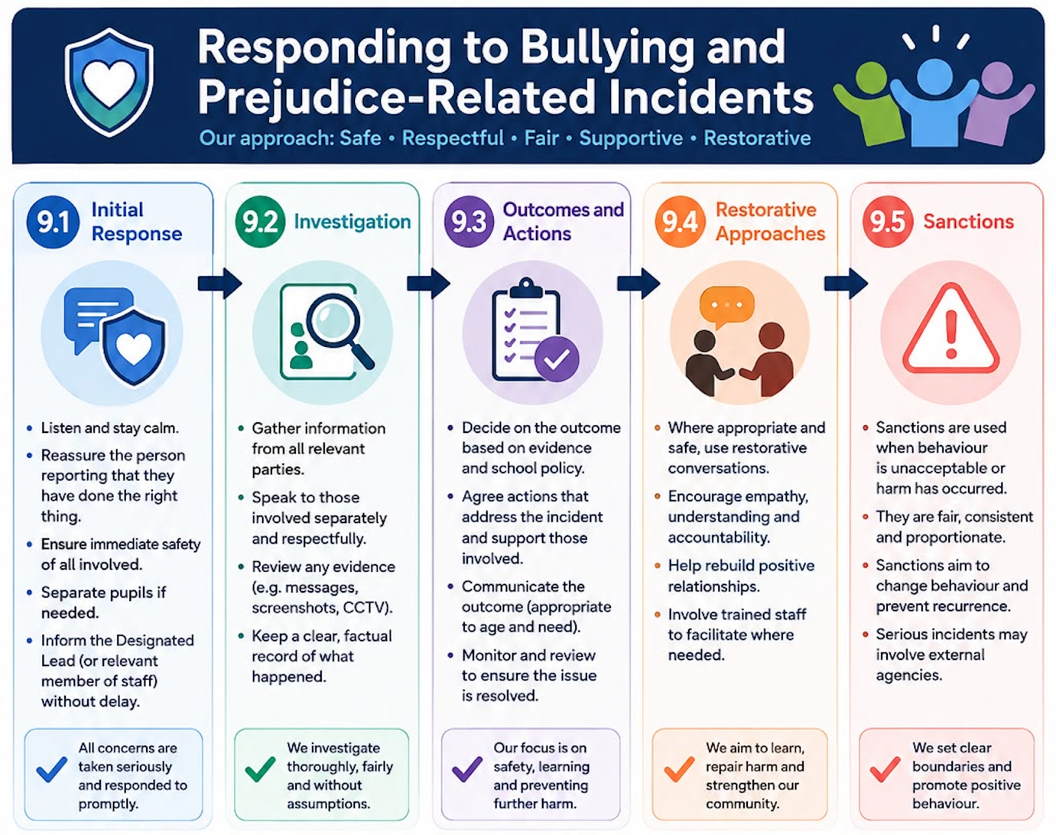
9.1 Initial Response
All incidents will be responded to promptly, consistently and sensitively. The immediate priority is to ensure the safety and wellbeing of everyone involved.
Staff will:
- listen carefully to all parties
- reassure those involved that concerns are taken seriously
- take immediate action to ensure safety (e.g. separating pupils if needed)
- record the concern in line with school procedures (See section 12)
- keep those involved updated about what will happen next to help reduce anxiety and build trust.

9.2 Investigation
All concerns will be investigated thoroughly and fairly. This process is essential in ensuring that decisions are accurate, proportionate and consistent.
Investigations will typically involve:
- gathering accounts from all parties involved
- considering the context and intent of the behaviour including whether behaviour was intentional or reflected discriminatory attitudes
- reviewing previous incidents or patterns
- identifying whether protected characteristics have been targeted
- consideration of SEND, communication needs and additional vulnerabilities
- whether behaviour constitutes child-on-child abuse
Senior leaders may support this process in more serious or complex cases to ensure consistency.
9.3 Outcomes and Actions
Following investigation, appropriate actions will be agreed to address the behaviour and support those involved.
Actions may include:
- restorative conversations
- targeted pastoral support
- behaviour interventions or monitoring
- parental involvement
- whether external agency advice is required

All actions will be:
- proportionate to the incident
- consistent with the Behaviour Policy
- focused on both accountability and learning

Outcomes will be recorded and reviewed to ensure they are effective in preventing reoccurrence.
9.4 Restorative Approaches
Restorative approaches play a key role in supporting pupils to reflect on their behaviour and rebuild relationships. These approaches are used where appropriate and are carefully facilitated by trained staff.
Through restorative work, pupils are supported to:
- understand the impact of their actions
- take responsibility for their behaviour
- rebuild trust and repair relationships

This approach aligns with the Trust’s values of respect, inclusion and empathy.
9.5 Sanctions
Where necessary, sanctions will be applied in line with the school’s Behaviour Policy to reinforce expectations and ensure safety.
Sanctions may include:
- loss of privileges
- time out or internal reflection
- behaviour plans or closer monitoring
- suspension in more serious cases

All sanctions will be:
- reasonable and proportionate
- applied consistently (where appropriate, adaptions may be necessary to meet individual needs, including SEND)

Sanctions are used alongside supportive approaches to promote long-term behaviour change.
10. Support for those involved
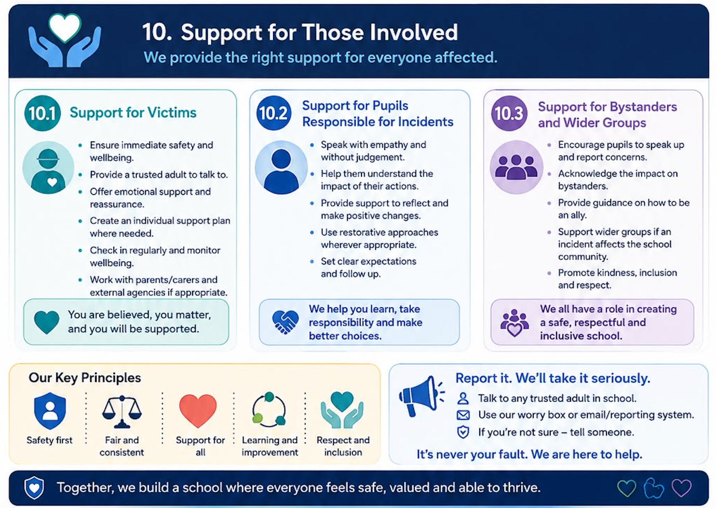
10.1 Support for Victims
Those who experience bullying or prejudice-related behaviour will receive timely and appropriate support to ensure their safety and wellbeing.
Support may include:
- regular check-ins with a trusted adult
- pastoral or emotional support (e.g. ELSA)
- adjustments to routines or environments
- support with friendships and confidence

The aim is to help everyone feel safe, rebuild confidence and maintain a positive sense of belonging.

10.2 Support for Pupils Responsible for Incidents
Pupils who display inappropriate behaviour will be supported to reflect, learn and improve. The focus is on behaviour change and understanding impact.
Support may include:
- structured reflective conversations
- behaviour support plans
- support with social skills or emotional regulation
- involvement of parents/carers

This approach ensures that pupils are supported to make better choices moving forward.
10.3 Support for Bystanders and Wider Groups
The wider impact of incidents is recognised, and support may be provided beyond those directly involved.
This may include:
- class discussions or circle time
- curriculum-based learning around respect and inclusion
- reinforcement of school values and expectations

This supports a proactive culture where everyone understands their role in maintaining a safe and inclusive environment.

11. Working with Parents and External Agencies
At Hales Valley Trust, we recognise that effective partnership working is essential in addressing bullying and prejudice-related incidents.
We work closely with parents and carers to:
- Ensure clear, open and timely communication
- Provide reassurance and support
- Agree appropriate actions and next steps
Working with External Agencies and Communication
Where appropriate, the school will work in partnership with external agencies to ensure that all incidents of bullying and prejudice are addressed effectively and that everyone receives the support they need. This may include collaboration with the Local Authority, safeguarding teams, police (where appropriate), and other specialist support services.
We are committed to maintaining clear and timely communication with parents and carers, as well as relevant external agencies, to ensure a coordinated and supportive response to each incident.

12. Recording and Monitoring
Recording Procedures
All incidents of bullying, discriminatory behaviour and prejudice-related incidents must be recorded promptly, accurately and in line with the school’s safeguarding and behaviour procedures. Recording is essential to ensure that concerns are taken seriously, patterns are identified, and appropriate action is taken.
Staff must:
- Take all reports seriously, regardless of intent, ensuring that pupils, staff and visitors feel listened to, supported and safe.
- Record incidents as soon as possible after they occur or are reported.
- Provide a clear, factual and objective account, avoiding opinion or assumption.
- Include:
  - Date, time and location of the incident
  - Names of all individuals involved (including witnesses)
  - A description of the behaviour/incident
  - Any protected characteristics targeted (e.g. race, religion, disability, gender, sexual orientation)
  - The voice of the child/young person where appropriate
  - Actions taken, including immediate response and follow-up
  - Outcomes and any next steps

All concerns, discussions, decisions made, and the reasons for those decisions must be recorded in writing. Records must be:
- Clear, comprehensive and chronological
- Kept confidential and shared only with appropriate staff
- Stored securely in line with safeguarding requirements

CPOMS Recording
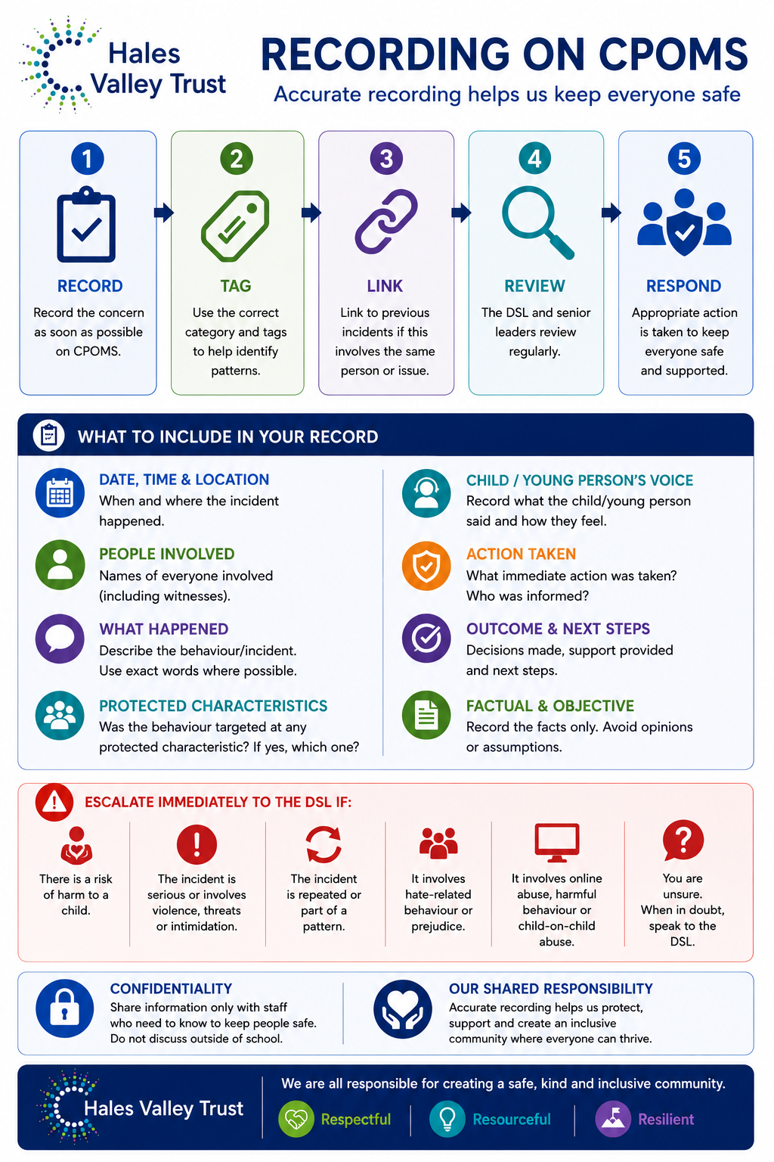
The school uses CPOMS (Child Protection Online Management System) to record and store all incidents relating to bullying and prejudice.
- All incidents must be logged on CPOMS as soon as possible by the member of staff who received or witnessed the concern.
- Relevant categories and subcategories must be used consistently to support accurate monitoring.
- Linked records should be used where incidents involve the same pupils or are part of a wider concern.
- The Designated Safeguarding Lead (DSL) and senior leaders will review entries regularly and determine any further safeguarding or pastoral actions required.
- Serious, repeated or high-level incidents must be escalated immediately to the DSL and/or Headteacher.
CPOMS records form part of the school’s safeguarding evidence base and may be used to inform external reporting, multi-agency work and statutory returns.
Monitoring Trends and Patterns
The school is committed to proactively identifying and addressing patterns of bullying and prejudice-related incidents.
Senior leaders and the DSL will:
- Regularly analyse CPOMS data to identify:
  - repeated incidents involving individual pupils
  - trends relating to specific types of prejudice (e.g. racist, homophobic, disability-related)
  - patterns linked to particular groups, times or locations within school

- Use this analysis to:
  - inform targeted interventions and support plans (e.g. APDR cycles, SEMH support, ELSA)
  - adapt curriculum provision (e.g. PSHE, assemblies, inclusive curriculum content)
  - review supervision, staffing and risk management arrangements
  - monitor the effectiveness of actions taken and adjust strategies accordingly

Where patterns indicate wider concerns, the school will take a whole-school approach, including staff training, pupil voice activities and parental engagement.
Reporting to Trustees
The school will ensure transparency and accountability through regular reporting to trustees.
- The Executive Headteacher/Headteacher will provide termly updates to the Trustees, which will include:
  - the number and types of recorded bullying and prejudice-related incidents
  - analysis of trends and patterns (without identifying individuals)
  - actions taken in response to incidents and their impact
  - any emerging concerns or areas for development

- Reports will be anonymised and comply with GDPR and safeguarding requirements.
- Governors and trustees will:
  - scrutinise the data and challenge where appropriate
  - monitor the effectiveness of the school’s anti-bullying strategy
  - ensure statutory duties under the Equality Act 2010 and safeguarding guidance are met

This reporting supports strategic oversight and ensures that the school maintains a proactive and inclusive approach to preventing bullying and discrimination.

13. Links with Safeguarding
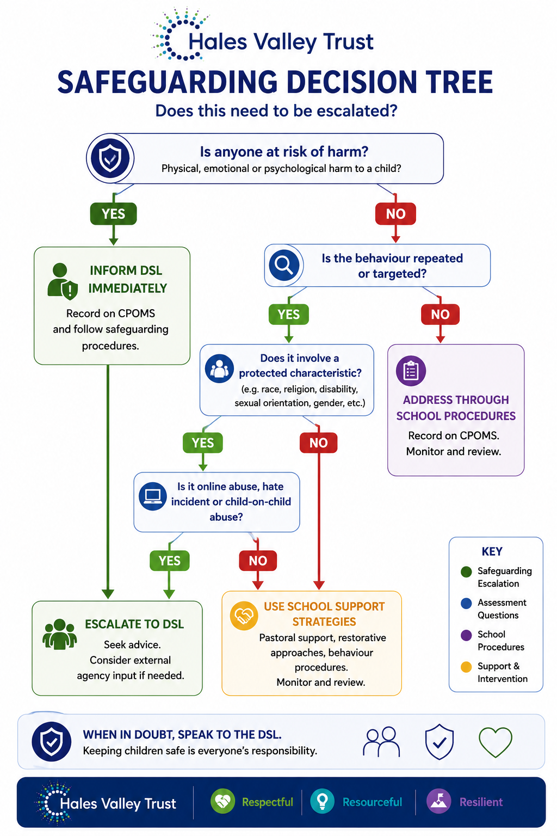
Bullying and prejudice-related incidents may, in some cases, constitute a safeguarding concern. At Hales Valley Trust, all such concerns are taken seriously and addressed in line with our Safeguarding and Child Protection Policy.
Staff understand that:
- some behaviours may indicate wider vulnerabilities or risks
- repeated or serious incidents may escalate to safeguarding concerns
- online incidents, harmful behaviour or hate-related incidents may require additional intervention

Where necessary, concerns will be escalated to the Designated Safeguarding Lead and managed in accordance with statutory guidance, ensuring that pupils are supported and protected at all times.
When Incidents Become Safeguarding Concerns
An incident will be treated as a safeguarding concern where:
- there is evidence of harm, risk of harm or ongoing targeting of a pupil
- the behaviour is persistent, severe or involves coercion, intimidation or exploitation
- there are wider indicators of abuse, neglect or vulnerability
- the incident involves online safety risks, hate-related behaviour or child-on-child abuse

In such cases:
- the DSL will be informed immediately
- a safeguarding record will be created on CPOMS
- appropriate action will be taken, which may include parental engagement, support plans, referrals to external agencies or statutory intervention
- all decisions and actions will be clearly recorded, including rationale and outcomes

Harmful Behaviour
Harmful behaviour may include behaviours that cause physical, emotional or psychological harm to others. This can range from bullying and discriminatory language to more serious actions such as threats, coercion or violence.
The school will:
- assess the intent, context and impact of the behaviour
- consider both the needs of the child displaying the behaviour and the child affected
- implement appropriate support, which may include SEMH interventions, behaviour support plans or pastoral provision
- ensure a proportionate and restorative approach alongside clear consequences

Where harmful behaviour is persistent or severe, it will be treated as a safeguarding concern and managed accordingly.
Online Abuse
Bullying and prejudice-related incidents may take place online, including through social media, messaging platforms, gaming or shared digital content.
Online abuse may include:
- cyberbullying or harassment
- sharing harmful, offensive or discriminatory content
- exclusion or targeting of individuals or groups
- the sharing of images or information without consent

The school will:
- respond to online incidents with the same seriousness as offline incidents
- investigate the incident fully, including capturing evidence where possible
- support pupils to stay safe online through education and guidance
- work in partnership with parents and, where necessary, external agencies

Serious online incidents will be referred to the DSL and may result in safeguarding action.
Hate Incidents and Extremism
Prejudice-related incidents, including those linked to race, religion, disability, gender or sexual orientation, may constitute hate incidents and, in some cases, raise concerns regarding extremism.
The school will:
- challenge and address all forms of discriminatory language and behaviour
- record all prejudice-related incidents on CPOMS using appropriate categories
- monitor trends to identify any wider patterns or concerns
- promote an inclusive curriculum that actively challenges prejudice and promotes respect

Where there are concerns relating to extremist views, radicalisation or hate-based behaviours:
- the DSL will be informed immediately
- appropriate safeguarding procedures will be followed, including consideration of Prevent duties
- external advice or referral may be sought in line with statutory guidance

Child-on-Child Abuse
Some bullying and prejudice-related incidents may fall under the definition of child-on-child abuse.
This may include:
- physical abuse
- emotional abuse, including sustained bullying
- sexual harassment or sexual violence
- coercive or controlling behaviour
- discriminatory or prejudicial abuse
The school recognises that:
- child-on-child abuse can happen both inside and outside of school, including online
- all children involved require support, including both the victim and the child displaying the behaviour
- such incidents must never be dismissed as ‘banter’ or ‘part of growing up’

In response, the school will:
- follow safeguarding procedures and inform the DSL immediately
- carry out a thorough and sensitive investigation
- provide appropriate support and protection for all pupils involved
- take action in line with behaviour, safeguarding and child protection policies

14. Monitoring, Evaluation and Review
The school regularly monitors and reviews its approach to preventing and responding to bullying and prejudice-related incidents to ensure it remains effective and compliant.
Reviewing Incident Data
- Incident data (CPOMS) is reviewed termly by senior leaders and the DSL.
- Patterns, repeat incidents and any concerns linked to protected characteristics are identified.
- Findings inform follow-up actions, support for pupils and any necessary safeguarding responses.

Evaluating Effectiveness of Preventative Work
- The impact of preventative work (e.g. PSHE, assemblies, pastoral support) is reviewed.
- Feedback from pupils, staff and parents is used to check how safe and included pupils feel, including survey results.
- Approaches are adapted where needed to improve impact.
- Success measures considered including: reduction in repeat incidents, attendance of affected pupils, reduction in prejudice-related language, staff confidence following training.

Equality Objectives and Improvement Planning
- Findings from monitoring contribute to the school’s Equality Objectives and improvement planning.
- Actions are included in relevant plans (e.g. behaviour, safeguarding, PSHE) with a focus on inclusion and reducing discrimination.

Policy Review Cycle
- This policy is reviewed annually or sooner if required.
- Reviews are informed by incident data, feedback and updates in guidance.
- Trustees receive updates and approve any significant changes.

Appendices
Appendix A: Definitions and Examples of Bullying
Examples of Bullying
Type of Bullying | Definition | Examples
Physical | Intentional use of physical force to harm or intimidate, often repeated. | Hitting, kicking, pushing, tripping, damaging belongings.
Verbal | Use of words to hurt, threaten or undermine another person. | Name-calling, insults, teasing, threats, spreading rumours.
Emotional / Psychological | Behaviour that negatively affects wellbeing, confidence or sense of belonging. | Exclusion, humiliation, intimidation, manipulation, isolating someone.
Indirect | Bullying carried out through others or behind someone’s back. | Encouraging others to be unkind, spreading rumours, social exclusion.
Sexual | Unwanted behaviour of a sexual nature causing distress or harm. | Inappropriate comments, unwanted touching, sharing sexual content.
Cyberbullying | Repeated harmful behaviour carried out through digital platforms. | Sending abusive messages, sharing images without consent, excluding someone online.
This list is not exhaustive.

Appendix B: Examples of Prejudice-Related Language and Behaviour
Examples of Prejudice-Related Language and Behaviour
Type | Definition | Examples
Racist | Behaviour or language targeting a person’s race or ethnicity. | Racial slurs, mocking accents, stereotyping, exclusion based on race.
Religion or Belief-Based | Behaviour targeting a person’s faith or beliefs. | Derogatory comments about religion, mocking religious practices.
Disability-Related | Behaviour targeting a person’s disability or additional needs. | Name-calling linked to disability, mimicking, excluding from activities.
Gender/Sex-Based | Behaviour based on gender stereotypes or sexism. | Comments such as “girls can’t…” or “boys don’t…”, unequal treatment.
Sexual Orientation-Based | Behaviour targeting actual or perceived sexual orientation. | Homophobic language, use of discriminatory terms.
Gender Identity-Based | Behaviour targeting a person’s gender identity or expression. | Misgendering, mocking identity or appearance.
General Prejudicial Language | Language or behaviour that reinforces stereotypes or discrimination. | “That’s so gay”, stereotyping groups, offensive jokes.
This list is not exhaustive.

Appendix C: Examples of Incident and Hate Crimes
Examples of Hate Incidents and Hate Crimes
Type | Definition | Examples
Hate Incident (non-criminal) | Behaviour perceived to be motivated by prejudice or hostility towards a protected characteristic. It may not meet the threshold for a criminal offence but is taken seriously due to its impact. | • Using racist, homophobic or discriminatory language (even if intended as a joke)  • Mocking a pupil’s accent, religion or cultural practices  • Name-calling linked to disability or additional needs  • Making stereotypical or derogatory comments about a group  • Sharing offensive or discriminatory memes or messages online  • Repeated use of phrases such as “that’s so gay”
Hate Crime (criminal offence) | A criminal offence motivated wholly or partly by hostility or prejudice towards a protected characteristic. This meets a legal threshold and may require police involvement. | • Physically assaulting someone while using racist or discriminatory language  • Threatening or intimidating a person because of their race, religion, disability or identity  • Deliberately damaging property with evidence of prejudice (e.g. discriminatory graffiti)  • Sending targeted, threatening or abusive online messages linked to protected characteristics  • Persistent harassment involving prejudice that causes fear or distress

Appendix D: How Our School Values Support Equality and Inclusion
How Our School Values Support Equality and Inclusion
The values of all schools within Hales Valley Trust are underpinned by the Trust's core values of being Respectful, Resourceful and Resilient.
Although each school has developed its own distinctive set of values that reflect its unique community and ethos, there are strong common threads that unite them. Values such as respect, kindness, caring, equality, cooperation, honesty and collaboration promote positive relationships, inclusion and acceptance of others, while values including aspiration, achievement, excellence, perseverance, resilience, learning and readiness encourage pupils to overcome challenges, develop confidence and become active participants in their education and wider community.
Together, these shared principles support the Trust's commitment to creating safe, inclusive and nurturing environments where diversity is celebrated, discrimination is challenged, and every individual is treated with dignity and respect. Through this collective approach, pupils are empowered to understand their rights and responsibilities, develop empathy and resilience, and contribute positively to a society that values fairness, equality and mutual respect.
British Values
British Values are a set of shared principles that help prepare children and young people for life in modern Britain. They promote the values of democracy, the rule of law, individual liberty, and mutual respect and tolerance of those with different faiths, beliefs and backgrounds. These values support the development of responsible, respectful and active citizens who understand both their rights and responsibilities within society. At Hales Valley Trust, we believe it is important that children understand how these values influence their everyday lives and the communities in which they live. Through learning about British Values, pupils develop an appreciation of fairness, equality, diversity and inclusion, as well as an understanding of how to contribute positively to their school, local community and the wider world. Children are encouraged to express their views, listen respectfully to others, make informed choices and challenge discrimination or prejudice when they encounter it. British Values provide an important framework for helping pupils understand the importance of living together harmoniously in a diverse society, while recognising that every individual should be treated with dignity, respect and fairness. These principles align closely with the United Nations Convention on the Rights of the Child (UNCRC) and the Equality Act 2010, supporting our commitment to safeguarding, inclusion, equality and the development of respectful, resourceful and resilient learners.
The United Nations Convention on the Rights of the Child (UNCRC)
The United Nations Convention on the Rights of the Child (UNCRC) is an international agreement that sets out the rights and freedoms that every child and young person should have, regardless of their background, nationality, culture, religion, ability or circumstances. Adopted by the United Nations in 1989, the Convention recognises that children have specific rights because of their age and need for protection, support and guidance as they grow and develop. The UNCRC contains 54 articles covering all aspects of a child's life, including the right to be safe, healthy, educated, listened to, protected from harm, treated fairly and able to participate in decisions that affect them. At Hales Valley Trust, we believe it is important for children to understand their rights and the responsibilities that accompany them. By learning about the UNCRC, pupils develop an understanding of how they should be treated and how they should treat others. This knowledge helps children recognise when their rights, or the rights of others, are not being respected and empowers them to seek support, speak out against injustice and contribute positively to creating safe, inclusive and respectful communities. The principles of the UNCRC align closely with British Values and the Equality Act 2010, promoting dignity, fairness, respect and equality for all.
Protected Characteristics and Equality
The Equality Act 2010 is a key piece of legislation that protects people from discrimination, harassment and victimisation. Within the Act, there are nine protected characteristics: age, disability, gender reassignment, marriage and civil partnership, pregnancy and maternity, race, religion or belief, sex, and sexual orientation. These characteristics help to ensure that individuals are treated fairly and with respect, regardless of who they are or their personal circumstances. At Hales Valley Trust, we believe it is important that children develop an age-appropriate understanding of equality, diversity and inclusion, and recognise that everyone has the right to be treated with dignity, fairness and respect. Through learning about protected characteristics, pupils develop an understanding of the rich diversity that exists within our schools, communities and wider society, while recognising that differences should be valued and celebrated rather than used as a reason for exclusion or discrimination. This knowledge helps children to recognise prejudice, challenge stereotypes and understand the impact that discriminatory language, bullying or behaviour can have on others. By promoting equality and fostering a culture of respect and belonging, we empower pupils to become active advocates for fairness and inclusion. The principles of the Equality Act 2010 align closely with British Values and the United Nations Convention on the Rights of the Child (UNCRC), supporting our commitment to safeguarding, promoting positive relationships and ensuring that every child feels safe, valued and able to thrive.
Actively Promoting British Values, Children's Rights and Equality
At Hales Valley Trust, we actively promote British Values, Children's Rights and Equality as interconnected principles that help create safe, inclusive and respectful school communities. Together, these frameworks provide children with the knowledge, understanding and values they need to thrive in modern Britain and contribute positively to society. Through British Values, pupils learn about democracy, the rule of law, individual liberty, and mutual respect and tolerance. Through the United Nations Convention on the Rights of the Child (UNCRC), they learn that every child has the right to be safe, heard, respected, protected from harm and treated fairly. Through the Equality Act 2010, pupils develop an understanding that everyone has the right to be free from discrimination and that differences should be valued and celebrated.
These three frameworks are closely linked. British Values help children understand how to live together respectfully within a diverse society; the UNCRC helps them understand their rights and responsibilities; and the Equality Act 2010 helps them understand that all people should be treated fairly regardless of their race, religion or belief, disability, sex, sexual orientation, gender reassignment, age, pregnancy and maternity, or marriage and civil partnership. Together, they provide a strong foundation for preventing bullying, discrimination and prejudiced behaviour.
We serve diverse communities and recognise the importance of helping children understand and appreciate the rich variety of cultures, backgrounds, beliefs and experiences that exist both within our local communities and across the wider world. Through our curriculum, assemblies, enrichment opportunities and daily interactions, pupils are encouraged to express their views, listen respectfully to others, challenge stereotypes, recognise unfairness and stand up against prejudice. By understanding their rights and the rights of others, children develop the confidence to recognise when those rights are being upheld and, importantly, when they are not. This empowers them to seek support, speak out against injustice and contribute positively to creating environments where everyone feels safe, valued and included.
Through this integrated approach, we foster respectful, resourceful and resilient learners who understand that diversity is a strength, discrimination is unacceptable and everyone has a responsibility to uphold the rights, dignity and wellbeing of others. This shared understanding underpins our commitment to preventing bullying, responding effectively to prejudiced incidents and promoting a culture of equality, belonging and mutual respect across all schools within Hales Valley Trust.
Teaching British Values, Children's Rights and Equality Through the Curriculum
At Hales Valley Trust, the promotion of British Values, Children's Rights and Equality is woven throughout our curriculum and everyday school life. Our Personal, Social, Health and Economic (PSHE) education curriculum, underpinned by guidance from the PSHE Association, provides a structured framework through which pupils develop their understanding of relationships, identity, diversity, rights, responsibilities, equality and citizenship. Through discussion, exploration and reflection, children are encouraged to consider different viewpoints, ask questions and engage thoughtfully with issues that affect themselves and others. Pupils are supported to express their views and opinions confidently, while also learning to listen respectfully to others, challenge ideas appropriately and respond constructively when their own views are questioned, extended or challenged. Through this learning, children develop an understanding of fairness, inclusion and belonging, as well as the confidence to challenge prejudice, discrimination and bullying when they encounter it.
These themes are further enriched through the study of high-quality texts in English, where pupils explore characters, themes, events and experiences that promote empathy, fairness, inclusion and social understanding. Through reading and writing, children examine issues such as equality, justice, discrimination, identity, belonging and human rights, enabling them to make meaningful connections between literature, their own lives and the wider world. By discussing the experiences of characters and considering different perspectives, pupils develop empathy and a deeper understanding of the impact that exclusion, prejudice and discrimination can have on individuals and communities. Opportunities for debate, discussion and collaborative learning encourage pupils to develop critical thinking skills and understand that respectful disagreement is an important part of democratic society.
Beyond PSHE and English, British Values, Children's Rights and Equality are embedded throughout our foundation curriculum. In history, pupils learn about significant individuals, societies and events over time, exploring how rights, freedoms and equality have developed and changed. In geography, children investigate diverse communities, cultures, countries and global issues, helping them to understand their place within an interconnected world and appreciate the experiences of others. Through religious education, pupils learn about different faiths, beliefs and worldviews, fostering mutual respect, tolerance and understanding. Across all subjects, children are encouraged to recognise and celebrate diversity, challenge stereotypes, understand protected characteristics and develop a deeper awareness of social justice and equality in the modern world.
Online safety is an integral part of our curriculum and is carefully woven through both computing and PSHE. Pupils are taught how to use technology safely, responsibly and respectfully, developing an understanding of their rights and responsibilities in digital spaces. Through discussion, modelling and real-life scenarios, children learn how to protect their personal information, recognise risks, and respond appropriately to concerns such as cyberbullying, online exploitation or exposure to inappropriate content. They are encouraged to think critically about the information they encounter online, understanding the importance of reliability, accuracy and digital footprints. Pupils are supported to speak up if they feel unsafe and are taught how to access trusted adults and reporting systems, ensuring they feel confident in navigating the online world safely and responsibly.
Oracy plays a central role in developing pupils’ confidence, voice and ability to engage thoughtfully with others. Across the curriculum, children are provided with regular opportunities to articulate their ideas, participate in meaningful discussion, and present their thinking clearly to a range of audiences. Through structured talk, debate and collaborative activities, pupils learn to justify their opinions, build on the ideas of others and respectfully challenge viewpoints. These experiences support the development of language, reasoning and critical thinking skills, while also promoting mutual respect and active listening. By valuing every pupil’s contribution, we foster an environment where children feel empowered to express themselves, understand diverse perspectives and engage positively in democratic processes.
Religious education provides a rich context through which pupils explore beliefs, values and ways of life from a range of faiths and worldviews. Through enquiry-based learning, children are encouraged to ask thoughtful questions, reflect on their own beliefs and consider the perspectives of others. They develop an understanding of how religion and belief influence individuals and communities, promoting respect, tolerance and open-mindedness. By examining themes such as identity, belonging, morality and social responsibility, pupils make connections between religious teachings and contemporary issues, including equality and human rights. This learning supports children in developing empathy, appreciating diversity and understanding the importance of living harmoniously within a pluralistic society.
Through this broad and ambitious curriculum, pupils are equipped with the knowledge, skills and values needed to become respectful, resourceful and resilient members of society. They develop the confidence to recognise when rights are not being upheld, understand the importance of treating others fairly and respectfully, and know how to seek support or report concerns if they experience or witness bullying, discrimination or prejudiced behaviour. In doing so, the curriculum plays a vital role in helping to create safe, inclusive and welcoming school communities where everyone feels valued, respected and able to thrive.

Why This Matters
At Hales Valley Trust, we believe that preventing bullying, discrimination and prejudiced behaviour is not solely achieved through responding to incidents when they occur, but through proactively creating a culture where respect, equality, inclusion and belonging are understood, valued and embedded within everyday school life. Our approach is underpinned by the Trust values of being Respectful, Resourceful and Resilient and is strengthened through the promotion of British Values, the United Nations Convention on the Rights of the Child (UNCRC), the Equality Act 2010 and the unique values of each of our schools. Together, these frameworks provide children with a shared language and understanding of rights, responsibilities, fairness and respect.
By teaching pupils about democracy, individual liberty, the rule of law, mutual respect and tolerance, children learn how to participate positively within diverse communities and recognise the importance of treating others with dignity and fairness. Through the UNCRC, pupils develop an understanding of their rights and the rights of others, including the right to be safe, heard, respected and protected from harm. Through learning about the Equality Act 2010 and protected characteristics, children gain an appreciation of diversity and develop the knowledge and confidence to recognise, challenge and report prejudice, discrimination and unfair treatment.
The curriculum, school values and wider experiences offered across the Trust help pupils understand that differences should be celebrated rather than feared, and that everyone has a responsibility to contribute to a safe and inclusive environment. The alignment between British Values, Children's Rights, Protected Characteristics and each school's values ensures a consistent Trust-wide approach while recognising the unique identity of each school community. This shared framework empowers children to recognise when behaviour is unacceptable, understand the impact of bullying and prejudice on others, seek support when needed and act as advocates for fairness, equality and inclusion.
Through this preventative and educational approach, we aim to foster school communities where every child feels safe, valued, respected and able to thrive, and where bullying, discrimination and prejudiced behaviour are actively challenged by all members of the school community.
Understanding the Connections
The table below demonstrates the strong alignment between British Values, the United Nations Convention on the Rights of the Child (UNCRC), the Protected Characteristics identified within the Equality Act 2010, and the values of each school within Hales Valley Trust. Although each school has its own distinctive ethos and values, the table highlights the common principles that unite them. It shows how concepts such as respect, fairness, inclusion, equality, responsibility, resilience and aspiration are reflected across all schools and are underpinned by the Trust's commitment to developing Respectful, Resourceful and Resilient learners.
The table also illustrates how British Values, Children's Rights and Equality are not taught as separate concepts. Instead, they work together to provide children with a clear understanding of how to treat others, how to recognise and challenge discrimination and prejudice, and how to contribute positively to their communities. By explicitly linking rights, responsibilities, protected characteristics and school values, the framework helps pupils understand that everyone has the right to feel safe, valued, respected and included. This shared understanding forms an important foundation for preventing bullying, responding to prejudiced incidents and promoting a culture of belonging across all schools within Hales Valley Trust.
The following table demonstrates how British Values, Children's Rights, Protected Characteristics and each school's values work together to develop pupils who are respectful, resourceful and resilient. It illustrates the consistent approach taken across Hales Valley Trust to promoting equality, inclusion, belonging and positive relationships, while preventing bullying, discrimination and prejudiced behaviour.

British Values (DfE) | Children's Rights (UNCRC – Child Friendly Language) | Protected Characteristics (Equality Act 2010) | Hurst Hill School Values | Lutley School Values | Gig Mill School Values | Priory School Values | Withymoor School Values | Lapal School Values | Woodside School Values | Shared Outcome for Pupils Across the Trust
Democracy  The right to vote, have your voice heard, and influence decision-making. | Article 12 – I have the right to share my ideas and adults should listen to me.  Article 13 – I can express my thoughts, feelings and opinions.  Article 15 – I can join groups, work with others and help make decisions. | All protected characteristics. | Honesty, Positive Attitude, Respect and Caring support children to share their ideas confidently, listen to others and ensure everyone is included. | Learning from others, working Together and Aiming High encourage active participation and positive contribution. | Respect, Equality, Collaboration, Honesty and Creativity ensure every voice is valued and heard. | Be Ready, Be Respectful and Be Safe create an environment where all pupils can participate confidently. | Being Respectful, Ready to Learn and treating others as they would like to be treated encourages participation and consideration of others. | Cooperation, Honesty, Kindness and Excellence promote collaboration and fair decision-making. | Care, Aspire and Achieve encourage pupils to contribute positively and make a difference. | Pupils develop confidence to express their views, participate in decision-making, listen respectfully to others and contribute positively to their communities.
The Rule of Law  Understanding that rules and laws protect society and apply equally to everyone. | Article 3 – Adults should make decisions that help me and keep me safe.  Article 19 – I have the right to be safe from harm.  Article 37 – I should be treated fairly and with kindness.  Article 40 – If I make a mistake, I have the right to be treated fairly and helped to make things right. | All protected characteristics, particularly disability, race, religion or belief, sex, sexual orientation and gender reassignment. | Honesty, Respect, Caring and Resilience help pupils take responsibility, follow rules and learn from mistakes. | Caring, Together and Learning support understanding of rights, responsibilities and safety. | Respect, Equality, Honesty, Perseverance and Collaboration promote fairness, accountability and positive behaviour. | Be Ready, Be Respectful and Be Safe encourage responsible choices and safe conduct. | Being Safe, Respectful and Resilient supports fairness, responsibility and learning from mistakes. | Honesty, Kindness, Perseverance, Cooperation and Excellence encourage children to do the right thing and respect others. | Care, Aspire and Achieve support responsible decision-making and positive citizenship. | Pupils understand that rules, laws, rights and responsibilities help to keep everyone safe, ensure fairness and support positive communities.
Individual Liberty  The freedom to make your own choices and express your beliefs, protected by law. | Article 13 – I can share my ideas and opinions.  Article 14 – I can have my own beliefs, religion and values.  Article 16 – I have a right to privacy.  Article 31 – I have the right to play, rest and enjoy activities that help me grow and learn. | Religion or belief, disability, sex, sexual orientation and gender reassignment. | Positive Attitude, Resilience, Honesty and Respect encourage confidence, self-expression and respect for others. | Aiming High, Learning and Caring help children develop independence while respecting others. | Creativity, Perseverance, Honesty, Respect and Equality support individuality and aspiration. | Be Ready, Be Respectful and Be Safe encourage responsible choices and respect for others' freedoms. | Being Ready to Learn, Resilient and Respectful supports independence and personal growth. | Perseverance, Excellence, Honesty and Kindness support ambition, self-belief and respect for others. | Aspire, Achieve and Care encourage pupils to pursue their goals while valuing others. | Pupils develop confidence, independence and self-belief while respecting the rights, freedoms and choices of others.
Mutual Respect and Tolerance  Respecting differing beliefs, faiths and opinions while treating others with dignity. | Article 2 – My rights belong to me whatever I look like, wherever I come from, whatever I believe, or whether I have a disability.  Article 14 – I can have my own beliefs and respect the beliefs of others.  Article 29 – My education should help me learn to respect other people, their rights and the world around me.  Article 30 – I can enjoy and celebrate my culture, language, religion and identity. | Race, religion or belief, disability, sex, sexual orientation, gender reassignment, pregnancy and maternity. | Respect, Caring, Honesty and Positive Attitude promote empathy, fairness and celebration of diversity. | Caring, Together and Learning encourage understanding, inclusion and community. | Respect, Equality, Collaboration, Honesty and Creativity promote fairness and appreciation of differences. | Be Respectful, Be Ready and Be Safe help create an inclusive environment where everyone belongs. | Being Respectful, Safe, Resilient and treating others as they would like to be treated promotes empathy and inclusion. | Kindness, Cooperation, Honesty and Excellence encourage positive relationships and respect for diversity. | Care, Aspire and Achieve support understanding, inclusion and positive contribution to society. | Pupils value diversity, challenge discrimination, demonstrate empathy and respect, and contribute to inclusive communities where everyone feels safe, valued and able to thrive.

Appendix E: Incident Response Flowchart

Incident Response Flowchart (Anti-Bullying & Prejudice Incidents)
Concern Raised (pupil / staff / parent / visitor)
↓
Listen and Reassure – take seriously, ensure safety
↓
Initial Action – separate if needed, inform staff
↓
Record on CPOMS – factual account
↓
Assess Incident – bullying? prejudice? pattern?
↓
Safeguarding Concern?
YES: Inform DSL immediately, follow safeguarding procedures
NO: Continue school investigation

↓
Investigate – gather accounts, review context
↓
Determine Outcome – restorative, sanctions, support
↓
Support for All – victim, behaviour, wider group
↓
Communicate with Parents
↓
Monitor and Review – check impact, patterns
↓
Follow-up if needed

Colour Key:
Reporting & Recording
Investigation
Safeguarding Escalation
Outcomes & Support

Appendix F: Recording and Monitoring Guidance
Recording & Monitoring
1. When a concern is raised
- Listen and take it seriously
- Ensure pupils are safe
2. Record on CPOMS (same day)
Include:
- Who was involved
- What happened (use exact words if possible)
- When and where
- Any protected characteristic targeted
- Action taken
Keep it factual
Use correct tags (e.g. bullying, racist, homophobic)
Link to previous incidents
3. Escalate immediately to DSL if:
- Risk of harm / safeguarding concern
- Serious or repeated incident
- Online abuse, hate-related behaviour or child-on-child abuse
4. School Response
- Investigate and gather information
- Take action (restorative, sanctions, support)
- Update CPOMS with outcomes
- Inform parents where appropriate
5. Hales Valley Trust Monitoring & Reporting Cycle
Class Teacher / Staff
⬇
Record concern on CPOMS
DSL / Senior Leaders
⬇
Review incidents regularly
Identify patterns, repeat concerns and safeguarding risks
School Level Monitoring
⬇
- Adjust support and interventions
- Inform pastoral support, APDR cycles, SEMH provision
- Review supervision / curriculum
Executive Head/Headteacher
⬇
Termly analysis of incidents
Identify trends (including prejudice-related incidents)
Trustees (Termly Safeguarding Report)
⬇
- Receive anonymised data
- Monitor trends and patterns
- Challenge and support school leaders
- Ensure safeguarding and equality duties are met

Appendix G: Useful Contacts and Support Organisations
DfE Behaviour and Discipline in Schools Guidance

Mental health and behaviour in schools advice for school staff

Counselling in schools a blueprint for the future: advice for school leaders and counsellors
Keeping Children Safe in Education (KCSIE)

Working together to safeguard children

Legislative links
Schools’ duty to promote good behaviour: Section 89 Education and Inspections Act 2006 and Education (Independent School Standards) (England) Regulations 2014
Power to tackle poor behaviour outside school

The Equality Act 2010

Specialist organisations
The following organisations provide support for schools and parents dealing with specific bullying issues including the social, mental or emotional effects caused by bullying.

The Anti-Bullying Alliance (ABA): Founded in 2002 by NSPCC and National Children's Bureau, the Anti-Bullying Alliance ABA) brings together over 100 organisations into one network to develop and share good practice across the whole range of bullying issues.
The ABA has also put together a fact sheet outlining the range of support that is available to schools and young people from the anti-bullying sector which can be accessed here.

The Diana Award: Anti-Bullying Ambassadors programme to empower young people to take responsibility for changing the attitudes and behaviour of their peers towards bullying. It will achieve this by identifying, training and supporting school anti-bullying ambassadors.

Kidscape: Charity established to prevent bullying and promote child protection providing advice for young people, professionals and parents about different types of bullying and how to tackle it. They also offer specialist training and support for school staff, and assertiveness training for young people.

The BIG Award: The Bullying Intervention Group (BIG) offer a national scheme and award for schools to tackle bullying effectively.

Restorative Justice Council: Includes best practice guidance for practitioners 2011.

Cyber-bullying and online safety
ChildNet International: Specialist resources for young people to raise awareness of online safety and how to protect themselves. Website specifically includes new cyberbullying guidance and a practical PSHE toolkit for schools.

Digizen: provides online safety information for educators, parents, carers and young people.

Internet Matters: provides help to keep children safe in the digital world.

Think U Know: resources provided by Child Exploitation and Online Protection (CEOP) for children and young people, parents, carers and teachers.

The UK Council for Child Internet Safety (UKCCIS) has produced a range of resources for schools, colleges and parents about how to keep children safe online, this includes advice for schools and colleges on responding to incidents of ‘sexting.’

LGBT
Barnardos: through its LGBTQ Hub, offers guidance to young people, parents and teachers on how to support LGBT students and tackle LGBT prejudice-based bullying

EACH: (Educational Action Challenging Homophobia): provides a national freephone Actionline for targets of homophobic or transphobic bullying and training to schools on sexual orientation, gender identity matters and cyberhomophobia.

Metro Charity: an equality and diversity charity, providing health, community and youth services across London, the South East, national and international projects. Metro works with anyone experiencing issues related to gender, sexuality, diversity or identity

Proud Trust: helps young people empower themselves to make a positive change for themselves and their communities through youth groups, peer support, delivering of training and events, campaigns, undertaking research and creating resources.

Schools Out: Offers practical advice, resources (including lesson plans) and training to schools on LGBT equality in education.

Stonewall: An LGB equality organisation with considerable expertise in LGB bullying in schools, a dedicated youth site, resources for schools, and specialist training for teachers.

SEND
Mencap: Represents people with learning disabilities, with specific advice and information for people who work with children and young people.

Changing Faces: Provide online resources and training to schools on bullying because of physical difference.

Cyberbullying and children and young people with SEN and disabilities: Advice provided by the Anti-Bullying Alliance on developing effective anti-bullying practice.

Anti-bullying Alliance SEND programme of resources: Advice provided by the Anti-bullying Alliance for school staff and parents on issues related to SEND and bullying.

Information, Advice and Support Service Network: Every Local area has an information, advice and support service, providing information, advice and support to disabled children and young people, and those with SEN, and their parents.

Mental health
MindEd: Provides a free online training tool for adults that is also available to schools. It can be used to help school staff learn more about children and young peoples mental health problems. It provides simple, clear guidance on mental health and includes information on identifying, understanding and supporting children who are bullied.

PSHE Association – guidance and lesson plans on improving the teaching of mental health issues

Race, religion and nationality
Anne Frank Trust: Runs a schools project to teach young people about Anne Frank and the Holocaust, the consequences of unchecked prejudice and discrimination, and cultural diversity.

Educate Against Hate: provides teachers, parents and school leaders practical advice and information on protecting children from extremism and radicalisation.

Show Racism the Red Card: Provide resources and workshops for schools to educate young people, often using the high profile of football, about racism.

Kick It Out: Uses the appeal of football to educate young people about racism and provide education packs for schools.

Tell MAMA: Measuring Anti-Muslim Attacks (MAMA) allows people from across England to report any form of Anti-Muslim abuse, MAMA can also refer victims for support through partner agencies.

Anti-Muslim Hatred Working Group: Independent members of this group are representatives from the Muslim community and will assist and advice on all relevant issues.

Please note that internal servers may block access to some of these sites. Schools wishing to access these materials may need to adjust their settings

Sexual harassment and sexual bullying
Ending Violence Against Women and Girls (EVAW): A Guide for Schools. This guide from the End Violence Against Women Coalition sets out the different forms of abuse to support education staff to understand violence and abuse of girls, warning signs to look for, and how to get your whole school working towards preventing abuse.

Disrespect No Body: a Home Office led campaign which helps young people understand what a healthy relationship is. This website includes teaching materials to be used in the classroom.

Anti-bullying Alliance: advice for school staff and professionals about developing effective anti-bullying practice in relation to sexual bullying.

Appendix H: Relevant Legislation and DfE Guidance

Scan the QR codes below to access key statutory guidance and legislation:
Keeping Children Safe in Education
https://www.gov.uk/government/publications/keeping-children-safe-in-education--2
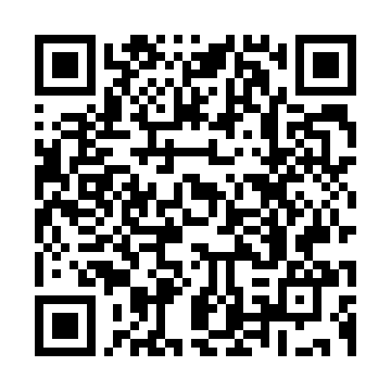
Prevent Duty Guidance
https://www.gov.uk/government/publications/prevent-duty-guidance
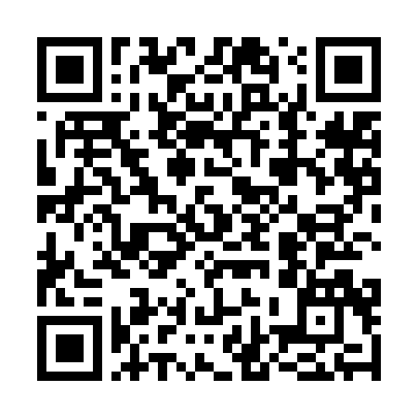
Preventing and Tackling Bullying
https://www.gov.uk/government/publications/preventing-and-tackling-bullying
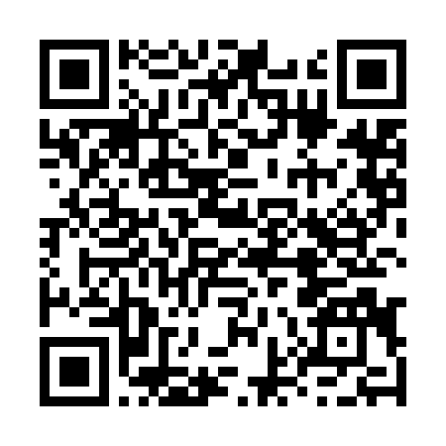
Behaviour in Schools
https://www.gov.uk/government/publications/behaviour-in-schools--2
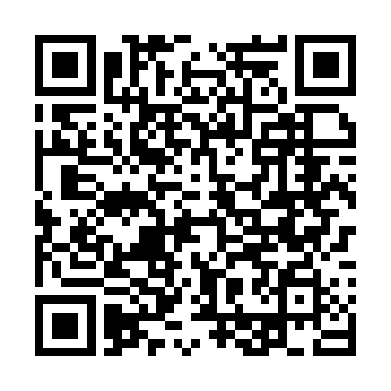
Equality Act 2010
https://www.legislation.gov.uk/ukpga/2010/15/contents


