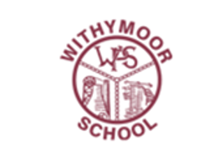
WITHYMOOR HISTORY CURRICULUM OVERVIEW
 | Autumn | Spring | Summer
EYFS | Understanding the World  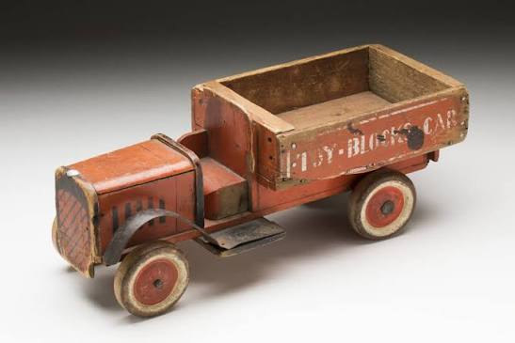  Comment on images of familiar situations in the past. Compare and contrast characters from stories, including figures from the past.  Society, Culture and Legacy | Past and Present  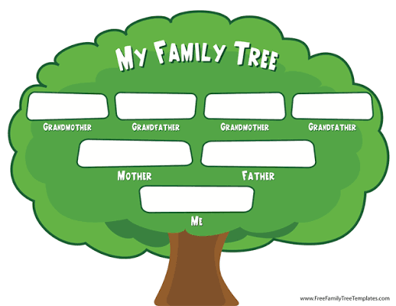  Talk about the lives of people around them and their roles in society.  Society, Culture and Legacy | Past and Present  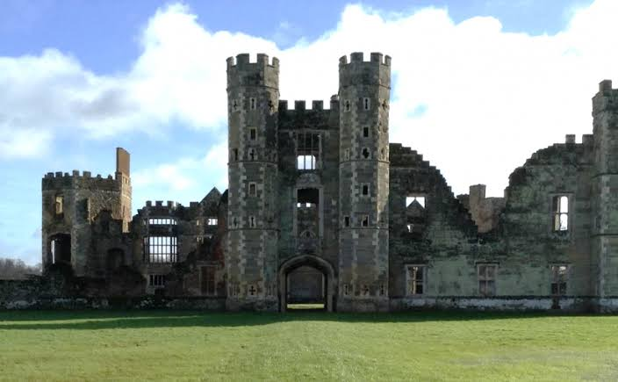  Know some similarities and differences between things in the past and now. Understand the past through settings, characters and events encountered in books and storytelling.  Society, Culture and Legacy
Year 1 | 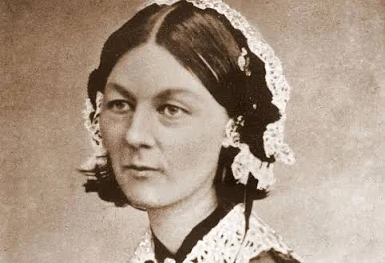  The Lives of Significant Individuals  Mary Seacole & Florence Nightingale and their impact on nursing  Society, Culture and Legacy | Significant Places in My Locality / Changes Within Living Memory  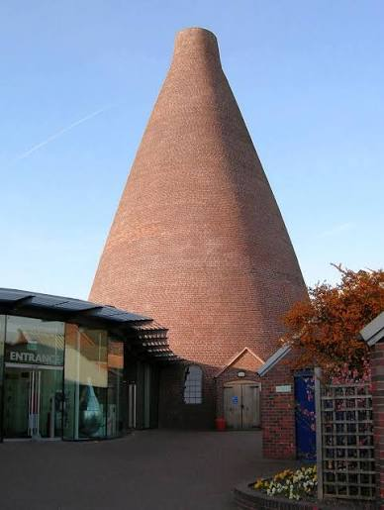  The Red House Glass Cone and its importance as one of the main industries of the area in the past  Society, Culture and Legacy | Events Beyond Living Memory  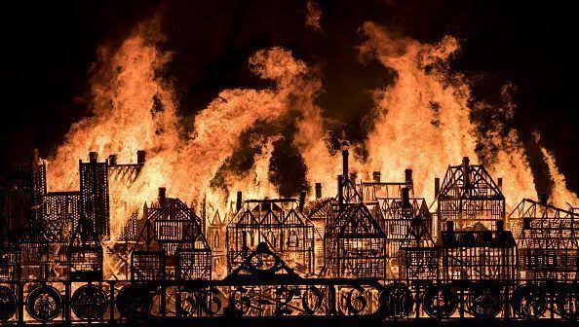  The Great Fire of London and its impact on life then and now  Conflict and Change
Prior learning | Reception Understanding the World – Talk about the lives of people around them and their roles in society. | Y1 T2 Geography – The Four Countries of the UK | Y1 T1 Geography – Local area knowledge
Year 2 | Significant Events in My Locality / Changes Within Living Memory  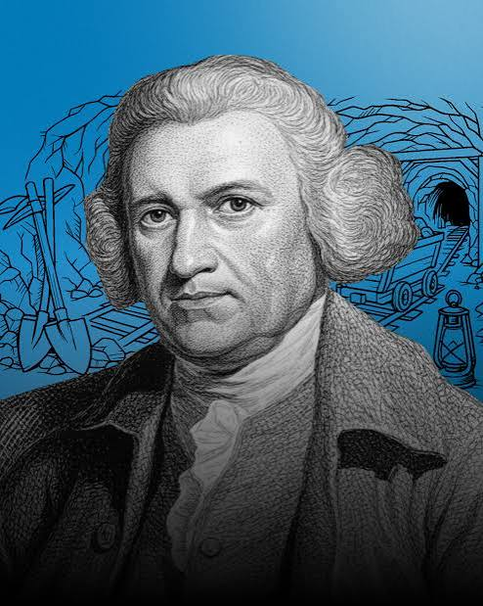  Transport – Thomas Newcomen: invention of the steam engine. The Stourbridge Lion and its significance in the history of trains  Society, Culture and Legacy | The Lives of Significant Individuals  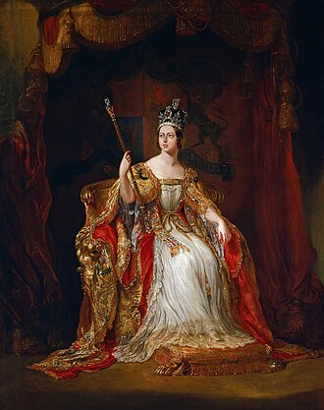  Queen Victoria – her national achievements and how she is remembered today. What was life like for children during her reign? Compare to modern day monarchy.  Monarchy and Power | Significant People in My Locality  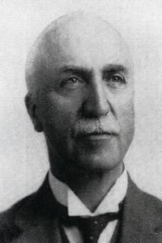  Ernest Stevens – his life and family, and his impact on the local area. The Bournville Brothers – how did they improve life for people in the area?  Society, Culture and Legacy
Prior learning | Y1 T1 Geography – Local area knowledge | Y1 T2 Geography – The Four Countries of the UK | Y1 T1 Geography – Local area knowledge  Y1 T3 History – Significant Places in My Locality / Changes Within Living Memory
Year 3 | Changes in Britain from Stone Age to the Iron Age  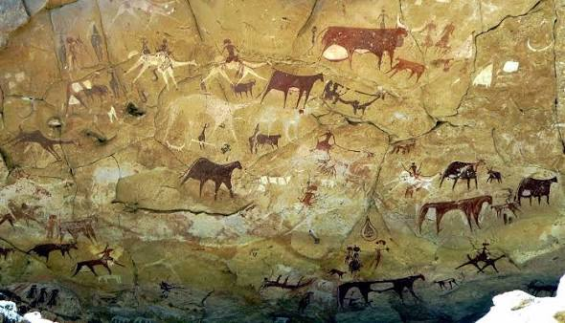  Compare aspects of life from the Stone Age, Bronze Age and Iron Age: settlements, farming, tools, art & religion  Migration and Settlement | The Roman Empire and its Impact on Britain  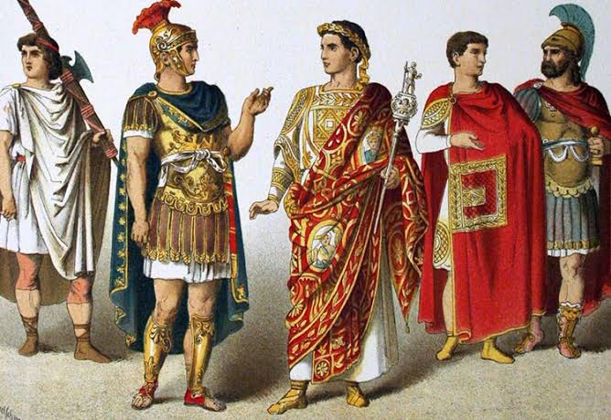  Why did the Romans come here and what impact did it have on Britain? Boudicca and the resistance  Empire, Expansion and Influence | The Achievements of Early Civilisations – Ancient Egypt  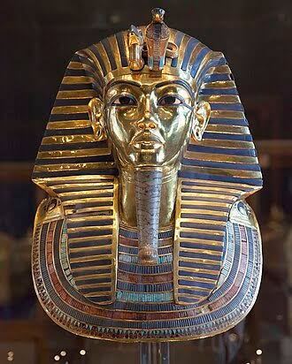  When and where was this early civilisation? Achievements: farming & irrigation, architecture & building, communication  Society, Culture and Legacy
Prior learning | EYFS & KS1 – Developing knowledge of the past as a concept  Y1 T2 Geography – The Four Countries of the UK  Y2 T1 Geography – What is the World? (knowledge of continents and oceans) | Y2 T2 Geography – What is the World? (knowledge of continents and oceans)  Y3 T1 History – Changes in Britain from Stone Age to Iron Age  Y3 T1 Geography – Mapping Europe (knowledge of countries in Europe) | Y2 T2 Geography – What is the World? (knowledge of continents and oceans)  Y3 T1 History – Changes in Britain from Stone Age to Iron Age  Y3 T3 Geography – Where does the River Sour flow? (including comparison to the Nile)
Year 4 | A Local History Study – The Victorians and the Impact of the Industrial Revolution  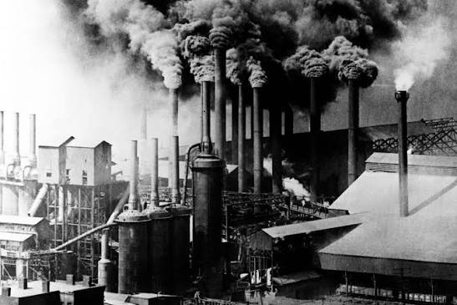  How have jobs changed over time in the local area? Farming & settlements, industrialisation, retail & business. What has the local and national impact been of the Industrial Revolution?  Society, Culture and Legacy | Britain’s Settlements by Anglo-Saxons and Scots  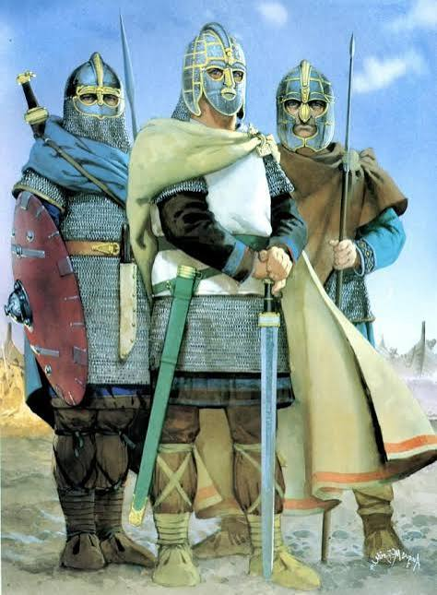  Why did the Romans leave and what happened to their Empire? Why did the Scots & Anglo-Saxons invade? What impact did it have on life in Britain?  Migration and Settlement | The Vikings’ Struggle for the Kingdom of England  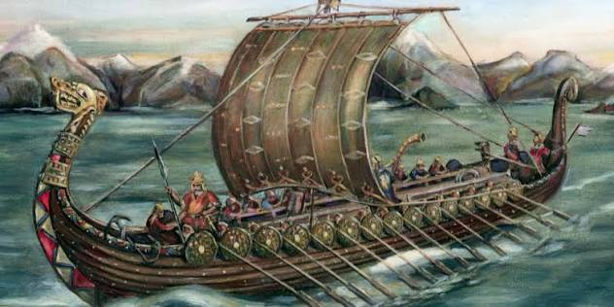  Why did the Vikings invade and who resisted them? What was Danegeld and why was it significant? Who was Edward the Confessor?  Conflict and Change
Prior learning | Y2 T1 History – Significant Events in My Locality / Changes Within Living Memory  Y2 T3 History – The Lives of Significant Individuals (Queen Victoria) | Y3 T2 History – The Roman Empire and its Impact on Britain | Y2 T2 Geography – What is the World? (knowledge of continents and oceans)  Y3 T1 Geography – Mapping Europe (knowledge of countries in Europe)  Y4 T2 History – Britain’s Settlements by Anglo-Saxons and Scots
Year 5 | A Study of an Aspect of British History – The Changing Power of Monarchs  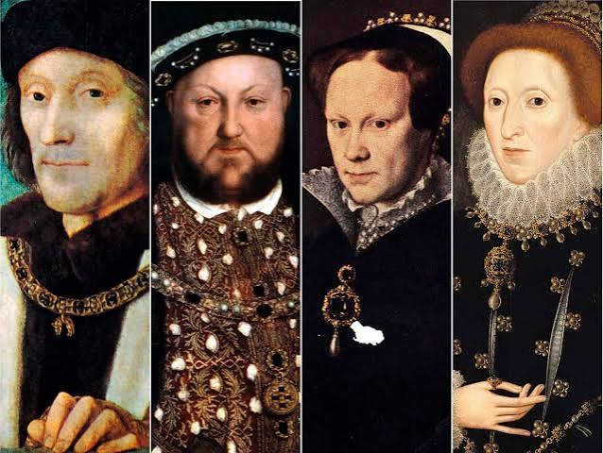  The start of the era of the Tudors and the Battle of Bosworth, Henry VIII and Elizabeth I  Monarchy and Power | A Study of a Theme in British History – Crime & Punishment  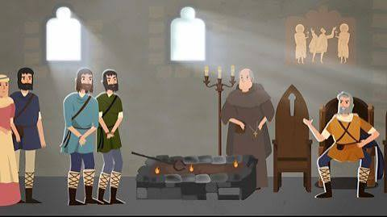  Compare crimes and punishments from the Anglo-Saxon period to now  Conflict and Change | The Achievements of Early Civilisations – Ancient Greece  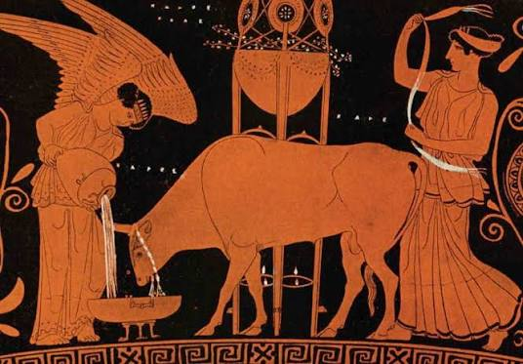  Their achievements and influence on the western world: Olympics, Democracy and the Arts  Society, Culture and Legacy
Prior learning | Y2 T3 History – The Lives of Significant Individuals (Queen Victoria – monarch)  Y3 T2 History – The Roman Empire and its Impact on Britain (invasion, rulers)  Y4 T2 & T3 – Anglo-Saxons, Scots & Viking (changing power of Kings) | Y4 T2 & T3 – Anglo-Saxons, Scots & Viking (changing power of Kings)  Y5 T1 – A Study of an Aspect of British History: The Changing Power of Monarchs (Tudors) | Y2 T2 Geography – What is the World? (knowledge of continents and oceans)  Y3 T1 Geography – Mapping Europe (knowledge of countries in Europe)  Y3 T3 History – The Achievements of Early Civilisations: Ancient Egypt
Year 6 | A Study of an Aspect of British History – The Battle of Britain  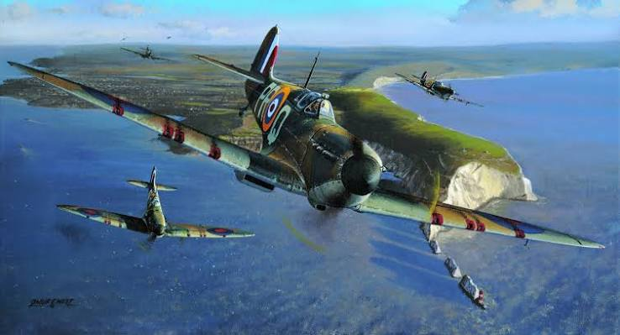  When did this occur? Why did it occur? Why was it a significant turning point?  Conflict and Change | History of a Non-European Society Study – Early Islamic Civilisation  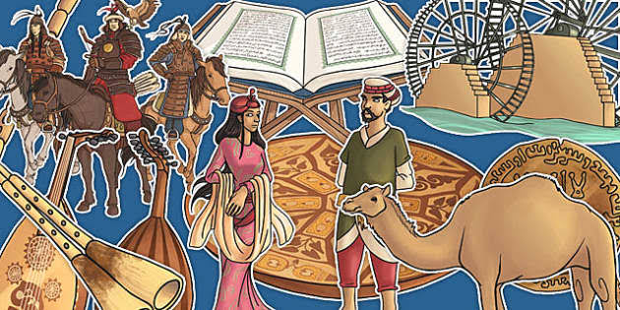  Compare aspects of life from early Islamic civilisations and compare it to British history at the time. Cities, beliefs, education and society roles.  Empire, Expansion and Influence | A Local History Study – The Foley Family  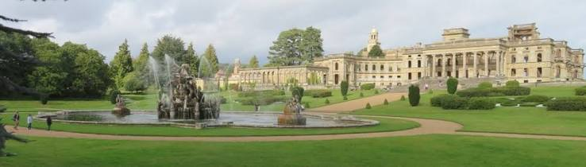  Their family history and impact on the local area and the role played by Major Frank Foley during WW2  Society, Culture and Legacy
Prior learning | Y2 T2 Geography – What is the World? (knowledge of continents and oceans)  Y3 T1 Geography – Mapping Europe (knowledge of countries in Europe) | Y2 T2 Geography – What is the World? (knowledge of continents and oceans)  Y3 T1 Geography – Mapping Europe (knowledge of countries in Europe)  Y3 T3 History – The Achievements of Early Civilisations: Ancient Egypt  Y5 T3 History – The Achievements of Early Civilisations: Ancient Greece | Y1 T1 Geography – Local area knowledge  Y1 T3 History – Significant Places in My Locality / Changes Within Living Memory  Y2 T2 History – Significant People in My Locality: Ernest Stevens & The Bournville Brothers  Y6 T1 History – A Study of an Aspect of British History: The Battle of Britain

WHOLE-SCHOOL HISTORY TIMELINE
Stone Age | Bronze Age | Iron Age |  | Ancient Egypt | Ancient Greece | Roman Britain |  | Anglo-Saxons | Early Islamic  Civilisation |  | Vikings | Tudors | Victorians /  Industrial Revolution |  | Second World War | Present Day
c. 2.6m BC–3300 BC | c. 3300–1200 BC | c. 1200 BC–AD 43 |  | c. 3100–30 BC | c. 800–146 BC | AD 43–410 |  | c. AD 410–1066 | c. AD 570–1258 |  | c. AD 793–1066 | 1485–1603 | 1837–1901 |  | 1939–1945 | Today
Migration and Settlement |  |  | Monarchy and Power |  |  |  | Empire, Expansion and Influence |  |  | Society, Culture and Legacy |  |  |  | Conflict and Change
Children revisit this chronological framework throughout the school to locate each unit in time and make connections across periods.

Golden threads

How the recurring historical narratives build across our curriculum
Golden Thread | What children explore | Year group | Where we see it
Migration and Settlement | How and why people move, settle and build communities. | EYFS | Family history, past and present, and the lives of people around them.
Migration and Settlement | How and why people move, settle and build communities. | Year 1 | Local area knowledge and changes within living memory.
Migration and Settlement | How and why people move, settle and build communities. | Year 2 | Transport, local change and the development of the local area.
Migration and Settlement | How and why people move, settle and build communities. | Year 3 | Stone Age–Iron Age settlements; Roman invasion and settlement in Britain.
Migration and Settlement | How and why people move, settle and build communities. | Year 4 | Anglo-Saxon, Scots and Viking settlement in Britain.
Migration and Settlement | How and why people move, settle and build communities. | Year 5 | Links to earlier learning about Anglo-Saxon and Viking settlement.
Migration and Settlement | How and why people move, settle and build communities. | Year 6 | Early Islamic civilisation and comparison between societies.
Monarchy and Power | Who holds power, how rulers gain and use it, and how leadership changes. | EYFS | Begin to understand that people had different roles in the past.
Monarchy and Power |  | Year 1 | Significant individuals and how people can influence change.
Monarchy and Power |  | Year 2 | Queen Victoria, her achievements and comparison with modern monarchy.
Monarchy and Power |  | Year 3 | Roman rulers and Boudicca’s resistance.
Monarchy and Power |  | Year 4 | Anglo-Saxon and Viking kings, including Edward the Confessor.
Monarchy and Power |  | Year 5 | The changing power of monarchs: Battle of Bosworth, Henry VIII and Elizabeth I.
Monarchy and Power |  | Year 6 | Leadership and decision-making during the Battle of Britain.
Empire, Expansion and Influence | How societies expand, encounter others and influence different places. | EYFS | Early understanding that the past includes people and places beyond children’s own lives.
Empire, Expansion and Influence |  | Year 1 | Developing knowledge of significant people and places.
Empire, Expansion and Influence |  | Year 2 | Developing wider national knowledge through Queen Victoria.
Empire, Expansion and Influence |  | Year 3 | The Roman Empire and its impact on Britain; Ancient Egypt and its achievements.
Empire, Expansion and Influence |  | Year 4 | Viking expansion and movement into Britain.
Empire, Expansion and Influence |  | Year 5 | Ancient Greece and its influence on the western world.
Empire, Expansion and Influence |  | Year 6 | Early Islamic civilisation: cities, beliefs, education and society.
Society, Culture and Legacy | How people lived, what they believed and valued, and what they left behind. | EYFS | Past and present through families, stories, characters and familiar situations.
Society, Culture and Legacy |  | Year 1 | Mary Seacole and Florence Nightingale; the Red House Glass Cone; Great Fire of London.
Society, Culture and Legacy |  | Year 2 | Victorian childhood, Queen Victoria and significant local people.
Society, Culture and Legacy |  | Year 3 | Stone Age–Iron Age farming, tools, art and religion; Ancient Egyptian achievements.
Society, Culture and Legacy |  | Year 4 | Victorian industry and jobs; Anglo-Saxon and Viking life in Britain.
Society, Culture and Legacy |  | Year 5 | Crime and punishment; Ancient Greek Olympics, democracy and the arts.
Society, Culture and Legacy |  | Year 6 | Early Islamic civilisation and the Foley family’s impact on the local area.
Conflict and Change | Why conflict happens and how events, ideas and people bring about change. | EYFS | Recognising simple differences between the past and now.
Conflict and Change |  | Year 1 | The Great Fire of London and its impact on life then and now.
Conflict and Change |  | Year 2 | Changes in transport and local life over time.
Conflict and Change |  | Year 3 | Roman invasion and Boudicca’s resistance.
Conflict and Change |  | Year 4 | Anglo-Saxon and Viking invasion, struggle and resistance.
Conflict and Change |  | Year 5 | Battle of Bosworth; changing monarchy; changes in crime and punishment.
Conflict and Change |  | Year 6 | The Battle of Britain as a significant turning point; Major Frank Foley during WW2.

How the threads progress
- EYFS and KS1 begin with familiar people, families, local places and simple examples of change over time.
- Lower KS2 broadens this through settlement, invasion, empire, ancient civilisations and local industrial history.
- Upper KS2 revisits these ideas in greater depth through monarchy, crime and punishment, Ancient Greece, the Battle of Britain and Early Islamic civilisation.
- By Year 6, children can make connections across periods and explain how migration, power, empire, society and conflict have shaped the past.

IMAGE SOURCES
Historical images and reference material
Mary Seacole
Wikimedia Commons – Portrait of Mary Seacole, c.1869, Albert Charles Challen. Public domain.
https://commons.wikimedia.org/wiki/File:Seacole_-_Challen.jpg
Florence Nightingale
Wikimedia Commons / Wellcome Collection – Florence Nightingale attending the wounded at Scutari. CC BY 4.0.
https://commons.wikimedia.org/wiki/File:Florence_Nightingale_attending_the_wounded_at_Scutari._Wellcome_M0003255.jpg
Florence Nightingale – teaching resources
The National Archives – Florence Nightingale education collection and primary sources.
https://www.nationalarchives.gov.uk/education/resources/florence-nightingale/
Mary Seacole – teaching resource
The National Archives – Mary Seacole source material.
https://www.nationalarchives.gov.uk/education/resources/florence-nightingale/mary-seacole-source-7/
Great Fire of London
Wikimedia/Wikidata – historical depiction of the Great Fire of London. Public domain.
https://www.wikidata.org/wiki/File:Great_Fire_London.jpg
Additional historical images
Wikimedia Commons – public-domain and Creative Commons historical photographs, paintings, artefacts and site images used as appropriate for individual curriculum topics.
https://commons.wikimedia.org/
Note: Image credits are kept on this separate page so the curriculum overview itself remains clear and uncluttered.

