Withymoor Geography Curriculum Overview
 | Autumn | Spring | Summer
EYFS | Understanding the world – People, Culture & communities  Our Local Area and the UK  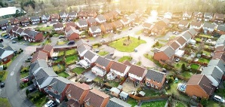 | Understanding the world – People, Culture & communities  The Wider World and Place  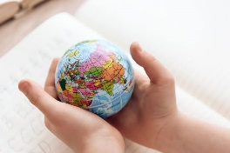 | Understanding the world – The Natural World  Weather, and Climate  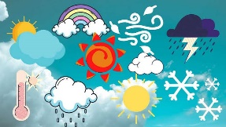
Year 1 | Geographical Skills & Fieldwork  Our Local Area  Our Local Area and the UK  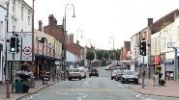  Location, Location, Location  (The school grounds) | Locational Knowledge  The Four Countries of the UK  Our Local Area and the UK  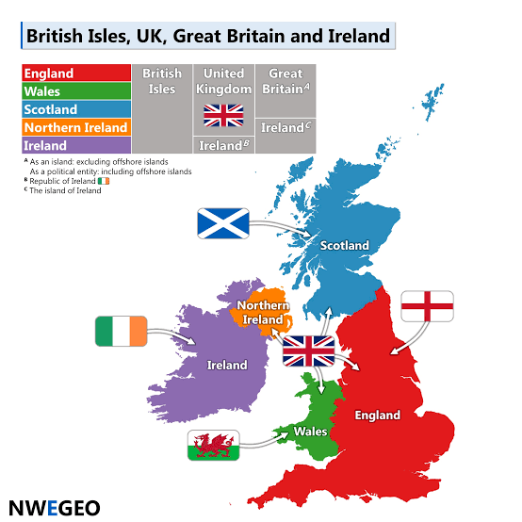  Brilliant Britain  (Mapping the UK) | Human & Physical Geography  What is the Weather like in our world?  Weather, Climate and Biomes  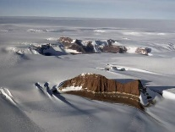  Brrr! It’s cold out there!  (North and south Pole, the equator)
Prior learning | Reception Understanding the world – People, Culture & communities | Y1 T1 Geography : Local area knowledge | Reception – Understanding the natural world  Y1 T1 Geography : Brilliant Britain
Year 2 | Locational Knowledge  Geographical Skills  What is the world?  The Wider World and Place  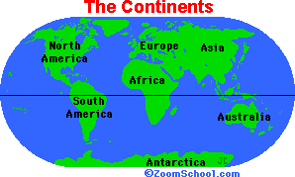  Names of continents & oceans  Use compass points and directional language | Locational Knowledge  Geographical Skills & Fieldwork  What is it like in different areas of the UK?  Our Local Area and the UK  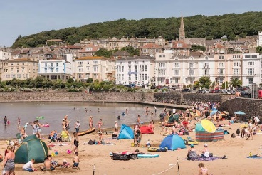  Wish you were here!  Comparing Dudley to another location in the UK (Weston-Super-Mare) , using maps and photographs  Visit: Weston Super Mare | Place Knowledge  Human & Physical Geography  How are places similar & different?  The Wider World and Place  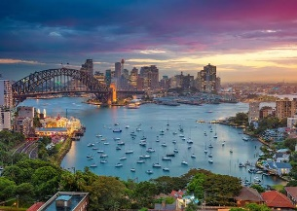  Life down under: Australia  Compare and contrast the human and physical geography of our locality with a locality in a non-European country.
Prior learning | EYFS: My home and our school  Year 1: Our school grounds and the immediate surrounding area | Year 1: Four countries of the UK | Year 1: Cold places  Year 2: The Continents and Oceans
Year 3 | Locational Knowledge  Geographical Skills  Our Local Area and the UK  How are the regions in the UK similar and different?  Counties surrounding the West Midlands | Locational Knowledge, Human & Physical geography,  Geographical Skills  The Wider World and Place  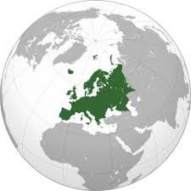  Mapping Europe  Countries, capitals, key physical & human characteristics of named countries | Human & Physical geography, Geographical Skills & Fieldwork  Mountain ranges  Landforms, Rivers and Natural Processes  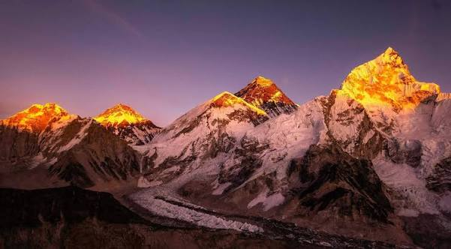  Mountains within the UK  Fieldwork: visit e.g. Wren’s Nest Hill, Carding mill valley
Y3 Prior learning | Year 1 – Local area – Brierley Hill and Withymoor.  Year 2: Wish you were here (What is it like in the UK) | Year 2: Continents and Oceans | Year 1: Brilliant Britain  Year 2: Wish you were here!
Year 4 | Locational Knowledge, Place knowledge, Geographical Skills  The Wider World and Place  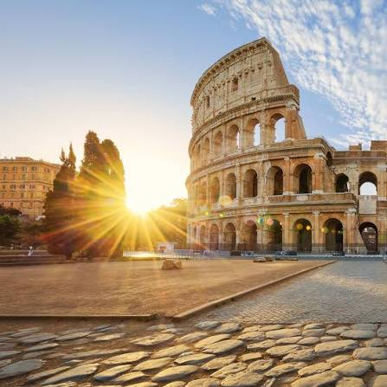  Visiting Europe  Compare and contrast the UK with other European countries (Rome-Italy and Greece-Athens  Identify geographical similarities and differences | Locational Knowledge, Human & Physical geography, Geographical Skills  Weather, Climate and Biomes  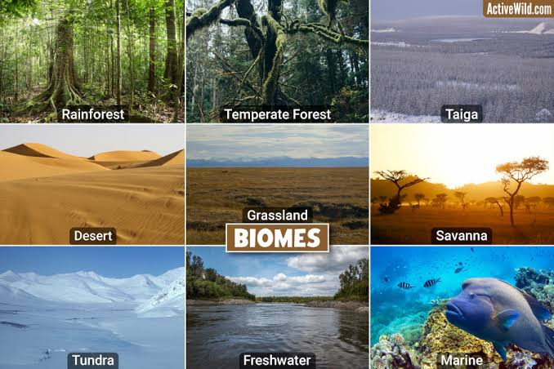  Climatic regions and biomes  How do geographers zone the world?  Name and locate the biomes of the world  Focus on Polar & tropical regions as a comparison | Locational Knowledge, Human & Physical geography, Geographical Skills & Fieldwork  Landforms, Rivers and Natural Processes  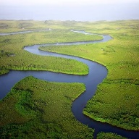  Rivers and the Water Cycle  Learn about the River Stour from source to mouth, including tributaries.  What is erosion and what causes it?  Compare with the river Nile  The Water Cycle  Visit: Severn Valley Country park to complete River study
Y4 Prior learning | Year 2: Continents and Oceans  Year 3: Mapping Europe  Year 3: How are regions in the UK similar and different? | Year 1: It’s cold out there!  Year 2: Continents and Oceans  Year 2: Life Down Under: Australia | Year 1: The UK  Year 2: Continents and Oceans  Year 3: Mountains
Year 5 | Locational Knowledge, Human & Physical geography, Geographical Skills  Weather, Climate and Biomes  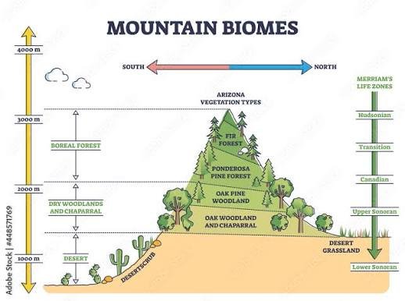  Mountain biomes  Compare and contrast the mountain ranges: The Andes (South America) and the Alps (Europe)  Location, size, vegetation, climate | Human & Physical geography, Geographical Skills & Fieldwork  Local area study  People, Resources and Sustainability  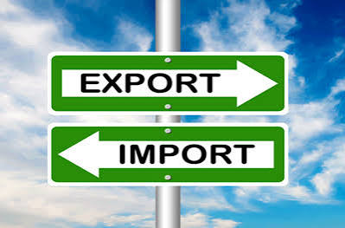  Trade and economics in our local area  How the area has changed over time. | Locational Knowledge, Human & Physical geography, Geographical Skills & Fieldwork  Landforms, Rivers and Natural Processes  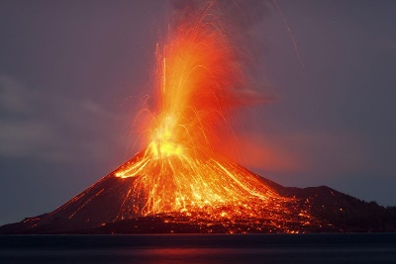  Our Fragile World  What is a volcano? Where in the world are they? Tectonic plates positions, causes and effects of these geographical events  Visit: Barrow Hill Nature reserve (Dudley Volacno)
Y5 Prior learning | Yr 2: Continents and Oceans  Yr 3: Mountains in the UK (Ben Nevis)  Yr 4: How do geographers zone the World? | Year 1: Local area  Year 3: How are the regions in the UK similar and different. | Year 3: Mountains in the UK  Year 5: Mountain biomes
Year 6 | Human & Physical geography, Geographical Skills  People, Resources and Sustainability  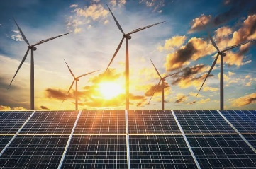  Energy and Sustainability  Renewable and non-renewable  Where in the world are these energies sourced and used? | Locational Knowledge, Geographical Skills & Fieldwork  The Wider World and Place  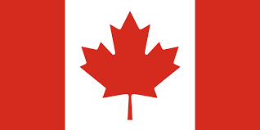  Compare and contrast the UK with Brazil and Canada  Countries, capitals, key physical & human characteristics of named countries | Geographical Skills & Fieldwork  Our Local Area and the UK  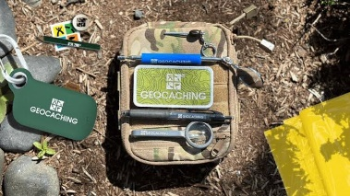  Geo-caching and OS benchmarks- using mapping correctly.  VISIT: geocaching and OS benchmark hunting in the local area (walking distance)  Orienteering at Baggeridge Country park
Y6 Prior learning | Year 2: Continents and Oceans  Year 3: Mountains in the UK  Year 5: Local area: changing land use over time.  Year 5: Mountain biomes  Year 5: Our fragile World | Year 1: Cold Places  Year 2: Continents and Oceans.  Year 4: How Geographers zone the World.  Year 5: Local Area: trade links  Year 6: Energy and Sustainability | Year 1: School grounds  Year 2: Wish you were here!  Year 3: How are regions in the UK similar and different?  Year 5: Local area study: Trade

GEOGRAPHY GOLDEN THREADS
Our Local Area and the UK | The Wider World and Place | Weather, Climate and Biomes | Landforms, Rivers and Natural Processes | People, Resources and Sustainability

WPS GEOGRAPHY - CURRICULUM STRUCTURE
Core geographical strands
Locational Knowledge  Knowing where places are and developing an increasingly secure mental map of the UK and wider world. | Place Knowledge  Understanding what places are like and comparing similarities and differences between places. | Human and Physical Geography  Understanding the human and physical features and processes that shape places and environments. | Geographical Skills and Fieldwork  Using maps, photographs, compass directions, observations and fieldwork to investigate places.
Golden thread progression
Golden Thread | What children learn | Year group | Where we see it
Our Local Area and the UK | How our immediate locality connects to regions and countries across the UK. | EYFS | People, Culture & Communities and familiar places.
Our Local Area and the UK |  | Year 1 | School grounds, local area and the four countries of the UK.
Our Local Area and the UK |  | Year 2 | Dudley and Weston-super-Mare; using maps and photographs to compare UK places.
Our Local Area and the UK |  | Year 3 | UK regions and counties surrounding the West Midlands.
Our Local Area and the UK |  | Year 4 | Links back to UK regions while comparing the UK with European countries.
Our Local Area and the UK |  | Year 5 | Local area study: trade, economics and how the area has changed over time.
Our Local Area and the UK |  | Year 6 | Geocaching, OS benchmarks and orienteering in the local area.
The Wider World and Place | Where places are, what they are like and how they compare across the world. | EYFS | People, Culture & Communities provides the foundation for understanding different places.
The Wider World and Place |  | Year 1 | UK location knowledge and the Equator, North Pole and South Pole.
The Wider World and Place |  | Year 2 | Continents and oceans; Australia compared with the local area.
The Wider World and Place |  | Year 3 | Mapping Europe: countries, capitals and key human and physical characteristics.
The Wider World and Place |  | Year 4 | Comparing the UK with Rome/Italy and Athens/Greece.
The Wider World and Place |  | Year 5 | Comparing the Andes and Alps and locating them within South America and Europe.
The Wider World and Place |  | Year 6 | Comparing the UK with Brazil and Canada, including countries, capitals and key characteristics.
Weather, Climate and Biomes | How weather and climate vary and how these patterns influence environments and biomes. | EYFS | The Natural World.
Weather, Climate and Biomes |  | Year 1 | Weather around the world; cold places, poles and Equator.
Weather, Climate and Biomes |  | Year 2 | Human and physical comparisons with Australia build awareness of contrasting environments.
Weather, Climate and Biomes |  | Year 3 | Mountain environments within the UK.
Weather, Climate and Biomes |  | Year 4 | Climatic regions and world biomes, with polar and tropical comparisons.
Weather, Climate and Biomes |  | Year 5 | Mountain biomes: Andes and Alps, including vegetation and climate.
Weather, Climate and Biomes |  | Year 6 | Prior learning about climate and biomes supports Energy and Sustainability.
Landforms, Rivers and Natural Processes | How physical processes shape mountains, rivers, coasts and other landscapes. | EYFS | The Natural World provides early experience of physical environments.
Landforms, Rivers and Natural Processes |  | Year 1 | Weather and cold regions introduce physical features and environmental differences.
Landforms, Rivers and Natural Processes |  | Year 2 | Comparing human and physical geography in the UK and Australia.
Landforms, Rivers and Natural Processes |  | Year 3 | Mountain ranges in the UK, including fieldwork at Wren’s Nest Hill.
Landforms, Rivers and Natural Processes |  | Year 4 | River Stour, tributaries, erosion, River Nile comparison and the water cycle; river fieldwork.
Landforms, Rivers and Natural Processes |  | Year 5 | Volcanoes, tectonic plates, causes and effects; Barrow Hill Nature Reserve visit.
Landforms, Rivers and Natural Processes |  | Year 6 | Physical geography is applied when considering energy sources and global locations.
People, Resources and Sustainability | How people use places and resources, how economies and land use change, and how we can live sustainably. | EYFS | People, Culture & Communities introduces how people live in places.
People, Resources and Sustainability |  | Year 1 | Local area and UK learning begins to connect people with places.
People, Resources and Sustainability |  | Year 2 | Human geography is compared between the local area and Australia.
People, Resources and Sustainability |  | Year 3 | Human characteristics of European countries are identified alongside physical features.
People, Resources and Sustainability |  | Year 4 | Place comparisons and world regions support understanding of how people live in different environments.
People, Resources and Sustainability |  | Year 5 | Trade and economics in the local area; change over time; Our Fragile World.
People, Resources and Sustainability |  | Year 6 | Renewable and non-renewable energy, where resources are sourced and used, and sustainability.

